Forces and Factors Influencing Melting Points,
Boiling Points and Other Physical Properties
A.K.A. Why is a compound a solid, liquid
or gas at a given temperature

In addition to understanding each chemical and physical operation carried out in the lab as it is carried out, it is very important to begin to understand that all physical and chemical properties observed for a compound are directly related to the compound's molecular structure. Therefore, you should eventually be able to predict physical and chemical properties after studying the molecular structure of a compound. It is my specific goal that you should be able to predict relative physical and chemical properties by the end of the course. For example, you should be able to tell which of a pair of related compounds has the higher boiling point. The following information should begin to help you meet this goal.

In order for a gas to liquefy or liquid to solidify, the molecules must have some attraction for one another. This is because as one proceeds from gas to liquid to solid, the molecules are more ordered and wind up in closer proximity. This attraction usually comes in the form of a charge or partial charge. For example, if a molecule or species is positively charged, it is very attracted to a negatively charged molecule or species. These attractions are called forces and the basic forces that help define the physical and chemical properties of molecules are outlined below.

lon-ion Forces.

These forces or attractions are the strongest. They involve the attraction between species bearing at least a full positive charge and a species bearing at least a full negative charge. The species involved can be simple ions (Na⁺CI⁻) or complex ions ((NH₄)+(CH₃CO₂)-). In the latter case, the charge is held by a covalently bound species. For example, the atoms within (CH₃CO₂)- are covalently bound, but the overall structure possesses a net negative charge. Fully charged species are so attracted to each other that they can get very close and form extensive ion networks. For example, you'll recall from general chemistry that NaCl forms networks in which each Na⁺ ion is closely surrounded by CI⁻ ions and each CI⁻ is closely surrounded by Na⁺ ions. Highly ordered, tightly packed networks of ions are called ionic compounds or salts. They are usually solids at room temperature that have very high melting points and boiling points. In other words, the solid state requires high order and close proximity of species. Ionic compounds are able to meet the requirements because of the strong electrostatic forces between the components of the compound.

Consider the following pair of compounds. The atoms in acetic acid are entirely covalently bound. Therefore, it has no strong ionic forces binding the molecules together. This is a significant part of the reason why acidic acid is a liquid at room temperature and not a solid. Sodium acetate on the other hand has an ionic link between the acetate (complex anion) and the sodium (cation). The strong electrostatic forces bring the species into highly ordered, close proximity. This is why sodium acetate is a solid at room temperature. A similar analysis can be applied to the following pairs of compounds. Check out the high boiling point of NaOH!
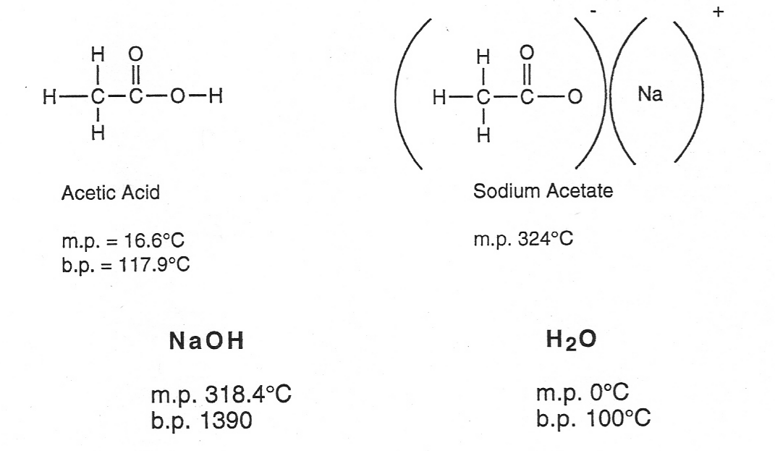

Dipole-Dipole Forces

Dipole-dipole forces are considerably weaker than ion-ion forces, but if significant, can have a large influence on physical properties. Dipole-dipole forces are important for molecules having net dipole moments, i.e., molecules having atoms with differing electronegativities arranged in such a way that the center of positive charge is different from the center of negative charge. In other words, the electron cloud is distorted so that an area(s) of the molecule is richer in electron density and another area is depleted of electron density. When in close proximity, the molecules will align themselves in such a way that the poles are complementary, i.e., δ⁺ with δ - and δ - with δ ⁺. As examples, consider hydrogen fluoride and chloromethane shown below.
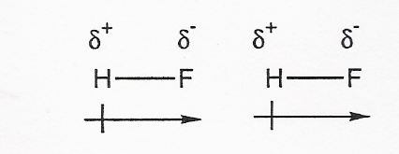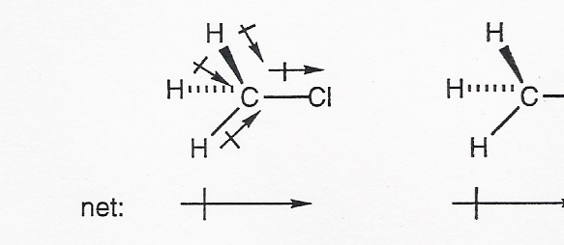

If the dipole moments are large, the attraction between the δ ⁺ and δ- of different molecules is strong and can serve to tightly pack the molecules into a solid.

Consider the following example of how changes in dipole moment can influence the boiling points of position isomers. Ignoring the benzene rings which both of the illustrated compounds have in common, ortho-xylene has a small net dipole moment and para-xylene has none. As you may have surmised from the previous examples, net dipole moments are vector quantities which are determined by "resolving" the individual bond dipole moments. The direction of the net dipole moment is based on the direction and magnitude of the individual vectors. If you haven't encountered vector resolution in your previous studies and you don't understand it, you should see your instructor. The fact that ortho-xylene has a larger dipole moment than p-xylene means that its binding forces are stronger and that more energy is needed to separate the molecules and send them into the gas phase. Therefore, o-xylene has a higher boiling point than para-xylene.
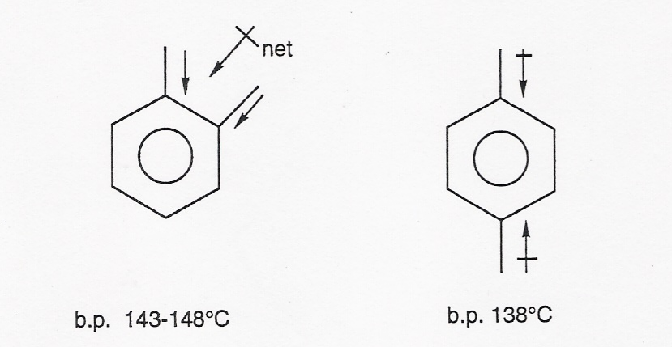

Hydrogen-Bonding
Strong dipole-dipole interactions, usually involving the hydrogen (δ⁺) on an oxygen, nitrogen or fluorine interacting with another nitrogen, oxygen or fluorine are given the special name, hydrogen bond. Realize though, that hydrogen bonds are not bonds, they are interactions. The energy of a mole of hydrogen bonds is approximately 5 kcal joulles, whereas a mole of RO-H covalent bonds has an energy of 103 kcals. For comparison, a standard dipole-dipole interaction is approximately 2-3 kcal/mol joulles.

Consider the following molecules and their respective boiling points to understand how profound an impact hydrogen-bonding can have.

CH₃CH₂OH CH₃-O-CH₃
b.p. 78.3°C b.p. -25°C
ethanol dimethyl ether

The above molecules are structural isomers and yet their boiling points differ by over 100°C! Why the big difference? Well, ethanol can hydrogen bond with itself and dimethyl ether can't. Ethanol forms a multiply hydrogen bonded network (illustrated on the next page) requiring a large input of energy to break up the cumulative interactions and vaporize the molecules.
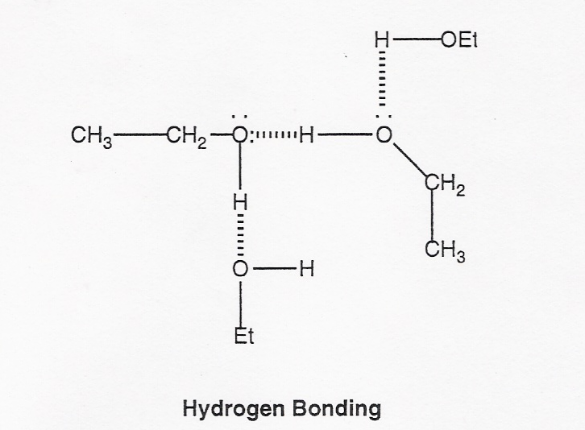

The dimethyl ether molecules do not have the requisite hydrogen on an electronegative N, 0 or F so they cannot act as hydrogen bond donors. Therefore, they do not hydrogen bond with each other. Though there are simple dipole-dipole interactions among the dimethyl ether molecules, they are much weaker as evidenced by the very low boiling point.

Hydrogen bonding is extremely important in biological systems. Can you think of some examples? Watch out! This is one of your instructor's favorite topics!

Van der Waals Forces

Why do non-polar substances have melting points or boiling points? Consider the physical properties given for methane.
Now these are very low numbers, but why would methane liquefy or solidify? What forces help to bind them together? The answer is Van-der Waals forces (also called induced dipole-induced dipole or London forces).
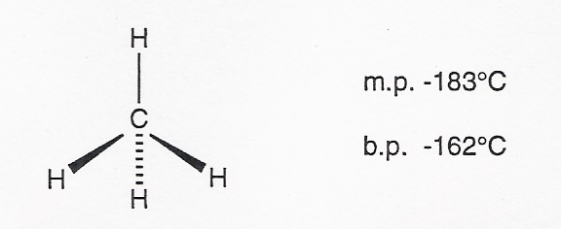

These relatively weak (but can be strong in large molecules) forces involve the cloud of electrons that encompasses any molecule. Even though we think of the methane (or any similarly symmetrical) molecule as being perfectly symmetrical, at any given moment in time the cloud is not. At any given moment, one side of the molecule might have a slight electron deficiency (δ⁺) and the other, a slight electron excess (δ -) due to repulsive interactions with surrounding methane molecules. This small dipole has an effect on the electron clouds of nearby molecules, inducing complimentary dipole moments. The small attractions between the dipoles lead to forces sufficient to allow methane to liquefy and solidify.

When molecules become larger, the Van der Waals forces become larger. This fact helps account for the nearly linear relationship between increases in boiling point with increasing numbers of carbons in a homologous series of organic compounds. For example, n-pentane boils at 36°C and n-hexane at 69°C.

Molecular Shape
In addition to the various forces delineated above, the shape of a molecule is very important to the ease with which it will pack into a crystalline lattice. Think about it. A crystalline lattice is a very tightly packed, orderly structure. If the molecules contributing to the lattice are rigid, compact and symmetrical, they tend to "fit" the best and tend to maximize interactions. Therefore, molecules having the described sort of desirable shape have higher melting points than their less compact relatives, i.e., it takes more energy to separate the molecules. An excellent example of this point is to consider the isomeric butanols, n-butanol and t-butanol. The much more compact, rigid and symmetrical t-butanol has a much higher melting point than n-butanol. This example also demonstrates another very important point, i.e., molecular shape does not have as profound an effect on the liquid to gas transition. Why is this so?
Another, possibly more interesting example involves the melting points of saturated vs. unsaturated fatty acids. Fatty acids are just long chain carboxylic acids. Consider stearic acid, an eighteen carbon, saturated fatty acid vs. oleic acid, an eighteen carbon, monounsaturated fatty acid.
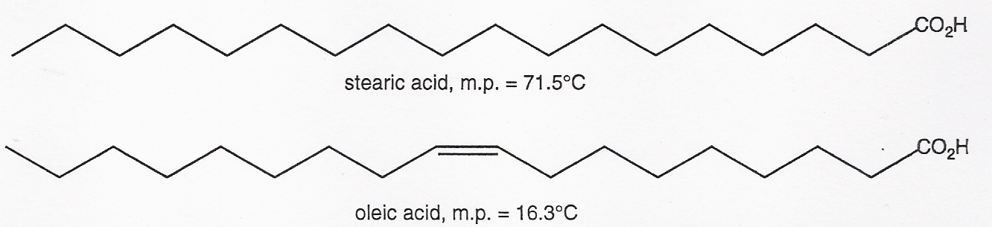

Obviously, stearic acid is a solid at room temperature and oleic is a liquid. When lipids crystallize they stack best in the favored zigzag, staggered conformation given.
The cis double bond (-120° angles) in oleic acid adds a "kink" to the chain, disrupting the order of the crystal. You should make models to prove this. Therefore, less energy is needed to cause the lipids to melt.

