**Experiment 7  
General Safety Considerations**

1. 1-Butanol and 1-bromobutane are toxic and irritating. Avoid all contact by **constantly** wearing goggles, gloves and working in the hood. Neither of these compounds can be poured down the drain. Like all products, 1-bromobutane should be turned in to your TA in a labeled vial. Any excess butanol should be discarded in non-halogenated waste.
2. H2SO4 is extremely corrosive. In very diluted form it can be poured down the drain, all other precautions described for butanol apply.
3. NaOH solution is corrosive. Handle it like H2SO4.
4. Methylene chloride is toxic and can be extremely irritating to your skin, especially when you are wearing gloves and it goes through them. It is not a bad idea to wear several pairs of gloves while working with it in addition to wearing goggles and working in the hood.
5. If you come in contact with any of the above mentioned chemicals, flush the exposed area for at least fifteen minutes with cold water. In the event of a major spill, consult your instructor.

7-1

**Chemistry 211-212 Preparative Experiments**

|  |  |  |
| --- | --- | --- |
| **Name**  **Chemistry 211-212 Investigative Experiments** | **TA Name:** | |
| **Experiment** # **7** | **Lab Day:** | |
| **Unknown** # | | |
| Section 1 (Pre-lab Sections I-VI) | | (20 points) |
| Section 2 (Results Sections VII - IX) | | (60 points) |
| Section 3 (Post-lab questions Section X) | | (50 points) |
| Quality of results | | (20 points) |
| TOTAL | | (170 points) |
| SCORE | | (percent) , |

**Please note that this lab will have a form write-up. You will be using a form to help you adjust to the changes in format involved in a preparative write-up. This means that your lab report will consist of this cover and the completed form that is found later in this section of the lab book.**

**You might also want to note that this is a two week experiment. While it is to your advantage to get as much of it done as possible during the first week, the prelab pages of the form will not be collected until the second week of the lab.**

**Please fill this page out and attach it to the pre-lab form pages when you are ready to submit them for grading.**

7-2

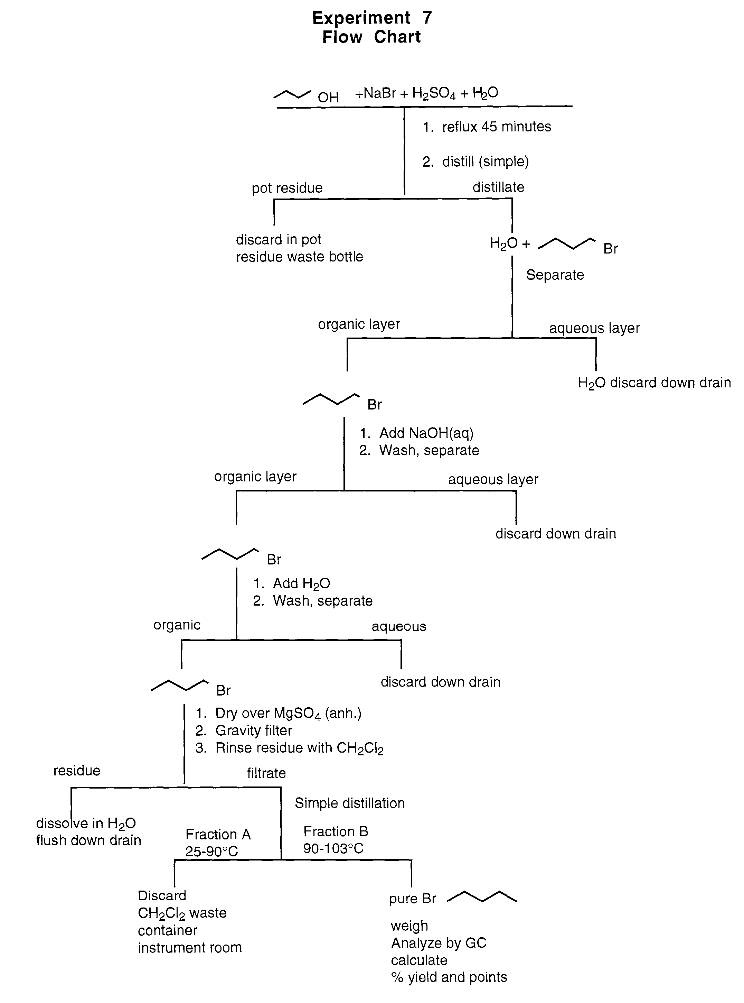

7-3

SN2 vs E2 vs SN1 vs El

|  |  |  |
| --- | --- | --- |
| **Best**  **Mechanism Rate Law Nucleophile/Base Substrate(s) Leaving Group Stereochem** | **Solvent** | **Temp** |
| SN2 Rate = k[Sub] [Nu] Strong Nucleophile 10(20-some Good (weak base) Usually Inversion  SN2 + E2)* Backside Attack  favored  Stereospecific | Polar  Aprotic | lower  temp |
| SN1** Rate = k[Sub] Weak Nucleophile 3°, allylic Good (weak base) Racemization or  benzylic (2° Partial Racemization  less reactive but Not stereospecific  also possible) | Polar  Protic | lower  temps |
| E2 Rate = k[Sub][Nu] Strong Base including 3°(2°-some Good (weak base) Anti periplanar  Bulky Base E2 + SN2)* transition state  preferred  stereospecific | Polar  Aprotic | higher  temps |
| E1** Rate = k[Sub] Weak Base 3°, allylic Good (weak base) Expect both  benzylic (2° Cis and trans  less reactive but products  possible) Not stereospecific | polar  Protic | higher  temps |

* 2° substrates are a gray area. With strong bases/nucleophile a mixture of SN2/E2 products will form. With a bulky base and/or higher temperatures, E2 products will dominate.

** SN1 and El compete with each other all the time so both products will form to a significant extent. Higher temperatures will favor El products, however.

7-4

**Experiment 7  
Nucleophilic Substitution: Preparation of 1-Bromobutane**

**The theory to support this lab can be found in chapters 9 and 10 of your textbook (Loundon).** In this preparative experiment, you will synthesize 1-bromobutane from butanol and hydrobromic acid as outlined in the following equation.

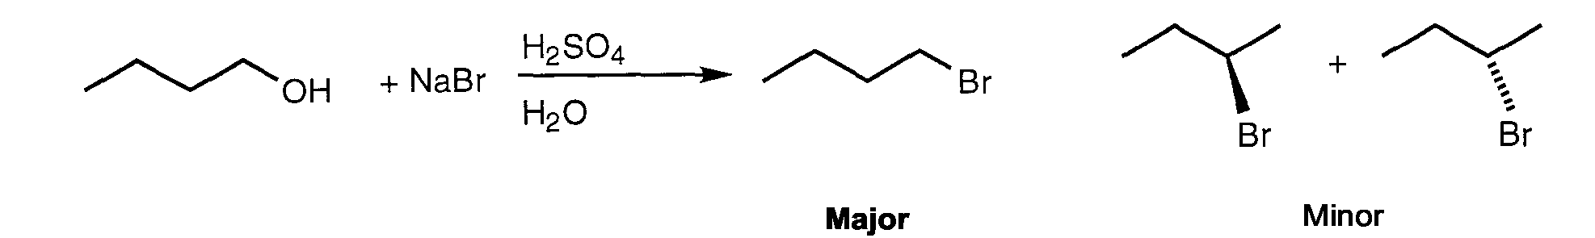

The formation of the major product, 1 bromobutane, can be explained by the following sequence of steps.

H2SO4 + H2O →H30+ + HSO4   
H30+ + Br→ HBr + H2O

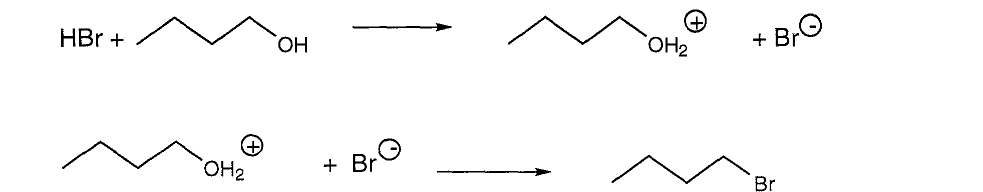

When you carry out the reaction , you will notice two layers in the reaction pot. The lower layer is aqueous and the upper layer is organic. It is believed that the nonionic HBr is the species that crosses the interface between the layers and protonates the hydroxyl group.

7-5

A possible explanation of the side product formation is via an elimination addition sequence, e.g.

7-6

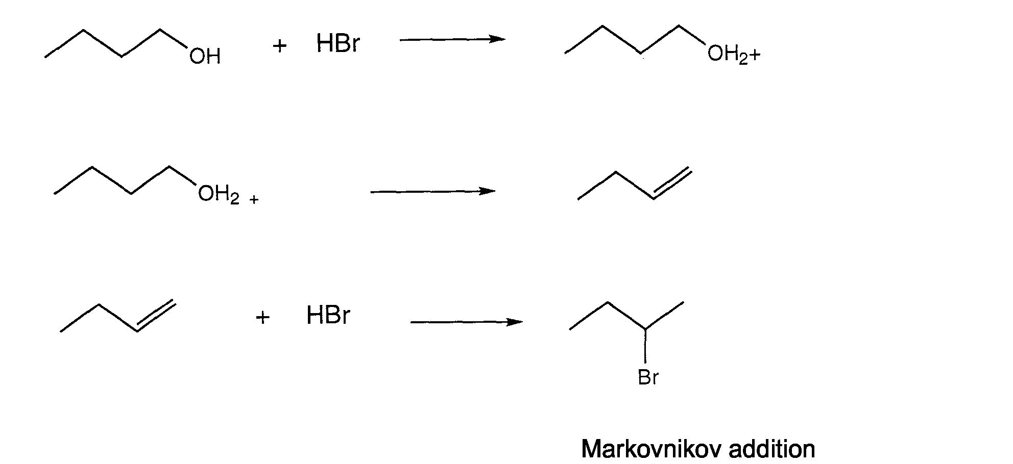

A new technique that arises in this experiment is that of steam distillation. When the first simple distillation in this experiment is carried out, you will not have a solution. Instead, you will have two layers. Unlike the distillation of a solution (see experiment 1), these two layers will behave as distinct entities and there will be no dependence on how much of each species is present. The total pressure of the pot liquids can be defined as in the following equation.

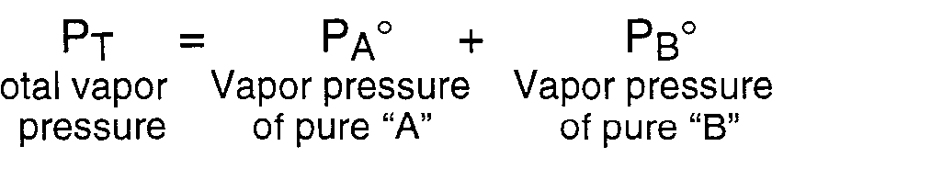

Notice there are no mole fraction terms in the equation. This means that if you have lots of water or just a little it will make the same contribution to the vapor pressure. What will happen when you distill? The mixture will heat up and water and bromobutane molecules will escape in proportion to their respective vapor pressures. Since both have boiling points close to 100°C, they should lift off in roughly equimolar proportions. Since they are not interacting with each other, no enrichment occurs and they will codistill at a single temperature until all of one component is distilled over. In this case, there is much more water than bromobutane from a molar perspective so considerable water will be left in the pot. The boiling point of the two together will be lower than the boiling point of the more volatile component. Why? At the end of the distillation, you will have two layers in the receiver which can be separated.

In prepartion for this lab study substitution and elimination in your text book answer the prelab questions on the pre-lab form that follows this text. **Please note: This is a form write-up. To save yourself time, please use the form provided following the text of this lab. The pre-lab questions will not be collected until the second week of this lab. Also due that day are the introduction, main reaction, mechanism, side reactions, purification and table parts of the form.**

**Procedure**

7-7

**Preheat your heating mantle at 30 volts. This will save you time later in the procedure.**

1. Add 0.05 mole of sodium bromide to a 50 mL round-bottomed flask followed by 6.0 mL of distilled water and 0.05 mole of 1-butanol. Mix the contents of the flask thoroughly and cool the flask in ice for 10 minutes. Keeping the flask in the ice bath, slowly add 6.0 mL of concentrated H2SO4. After each small addition of acid, swirl the flask to mix and allow it to cool for one minute in the ice bath. It should not take more than five or six minutes to add the concentrated acid.
2. Remove the flask from the ice bath and add two or three boiling stones. Equip the flask for reflux and attach the trap illustrated below. The funnel should be just touching the water in the beaker. There should be a clamp on the neck of the round bottom, the condenser and the trap.

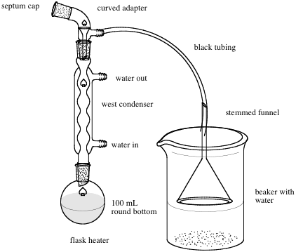

**Reflux Apparatus: Experiment 7**

1. Since the round bottom contains a moderate volume, it will take a long time to reach reflux using a conservative heating rate. Instead set the power mite at 50 or 60 until the reflux begins and then turn it down to 40 or 50 to maintain the reflux. Adequate reflux for this experiment is a steady (1 drop/sec) flow of condensate from the condenser which usually requires boiling in the reaction pot. Allow the reaction mixture to reflux at a rate of 1 drop per second for 45 minutes.
2. Allow the reaction to cool slightly and then equip the round-bottom for simple distillation. Rapidly co-distill water and 1-bromobutane until freshly collected distillate is clear and homogeneous. Although most of the distillate will be collected below 100°C (why?), do not allow the head temperature to go above 110°C. What material is being collected at elevated temperatures. Due to the small amounts of material collected, students frequently collect the distillate directly into the very small dropping funnel that is part of the kit.

**7-8**

1. Assuming your distillate is already in the very small, pear shaped funnel, separate the layers and identify them as organic and aqueous. You should find the layers to be very intriguing, if not a bit confusing. Procede with care. Which layer should be on top? Which layer should have largest volume. Do not throw out any layers until you are absolutely sure which layer is which. Wash the organic layer sequentially with 2.0 mL of 2M sodium hydroxide solution, followed by 3.5 mL of distillated water.
2. Place the sample in a vial and dry it with anhydrous MgSO4 . It can be filtered through a small piece of fast filter paper into a tared vial. Alternatively, to improve yield, you can dry the organic layer using the Pasteur pipet drying technique demonstrated in the You tube associated with this procedure (see the schedule page). The Pasteur pipet should be packed with 1-1.5 cm of dry MgSO4. and the sample should be filtered into a small, taredvial.
3. Obtain the mass of the product and analyze the product by G.C.

**Please complete the form that follows this page. This is your lab report.**

**Experiment 7**

**Form Write-up**

**I. Pre-lab Exercises (20 points)**

1. Critique (i.e., will it work? If not, why not?) the following proposed synthesis of 1-bromobutane. (3 points)

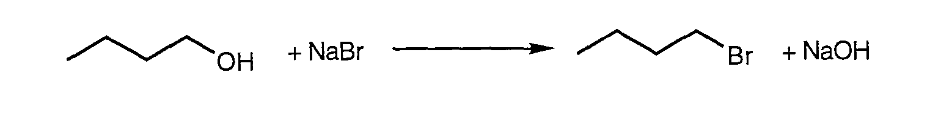

1. In view of your answer to 1, what is the function of the acid in the reaction you will carry out in lab? How is hydrobromic acid formed from the reagents given? (3 points)
2. Write a complete mechanism (arrow formalism) describing how 2-bromobutane might be formed under the experimental conditions. (6 points)

**7-9**

4. All the side reactions can be summed up as follows. This should help you with the prior problem.

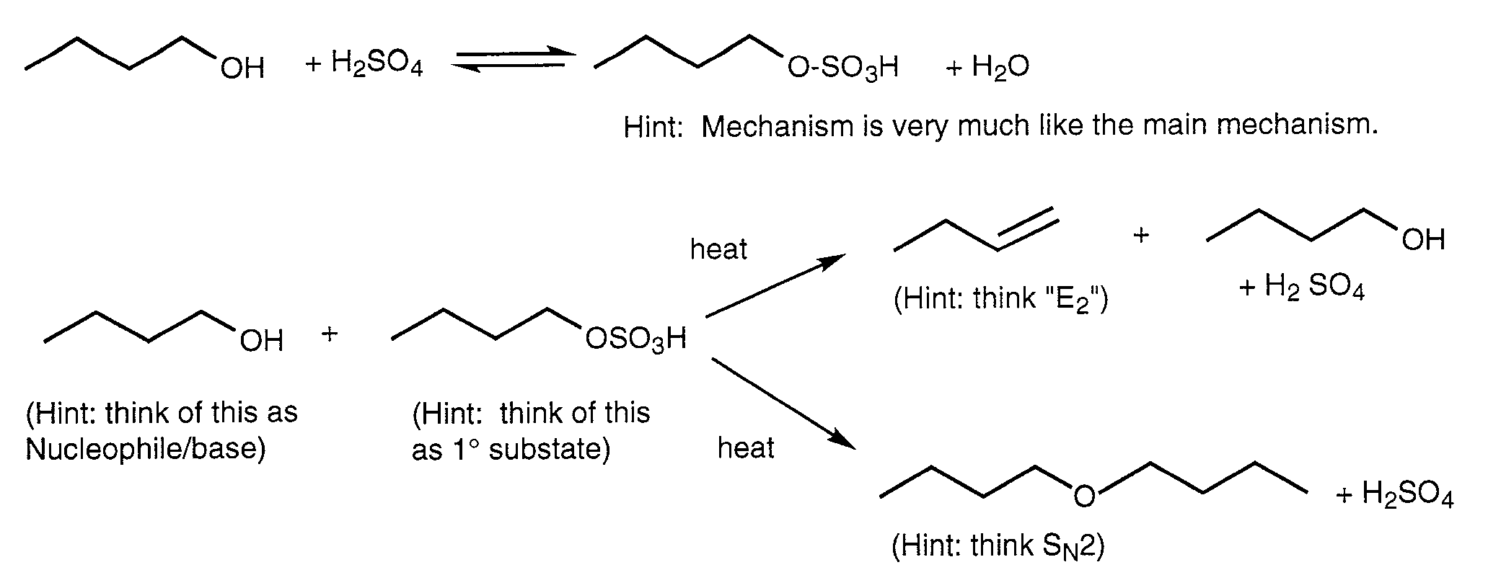

Propose reasonable ionic mechanisms (arrow formalism) describing the formation of these side products. (8 points)

**7-10**

**Experiment 7 Form Continued**

**I Introduction: (8 points)**

**II. Main Reaction: (4 points)**

**III. Mechanism (12 points)**

**7-11**

**IV . Side Reactions and Minimization of Side Reactions: (See Pre-lab - equations are needed only)**

**V . Purification:**

**Purification Step Contaminants Removed**

1. Steam Distillation ( 2 points)
2. Layer Separation (1 point)
3. Base Wash (2 point)
4. Water Wash (1 point)
5. Addition of MgSO4 (1 point)
6. Gravity Filtration (1 point)

|  |  |  |  |  |
| --- | --- | --- | --- | --- |
| **VI. Table of Reagents: (10 points)** | |  |  |  |
| **Reagent** | **MW/molarity grams or mL** | **moles** | **b.p./m.p.** | **density** |
| 1-butanol  NaBr  H2SO4 |  |  |  |  |

|  |  |  |  |  |  |
| --- | --- | --- | --- | --- | --- |
| **VII. Table of Products: (8 points)** | |  |  |  |  |
| **Product** | **MW/molarity** | **grams or mL** | **moles** | **b.p./m.p.** | **density** |
| 1-bromobutane |  |  |  |  |  |
|  |  |  |  |  |  |

1. **Observations: (8 points)**
2. **IX Results: (22 points)**

boiling range of product: (1 point)

appearance of product: (2 points)

yield of product in grams: (1 point)

yield of product in moles: (2 points)

percent yield of product: (2 points)

GC Data:

GC retention times and peak identification: (6 points)

Areas of GC peaks (4 points)

**7-14**

Percent purity of products: (4 points)

**X . Discussion:**

**Evidence supporting identity of product: (6 points)**

**Reasons yield is less than one hundred percent: (8 points)**

**Purity of sample and possible contaminants. (6 points)**

**7-15**

**XI. Post-lab Exercises**

a. Explain the effect of adding too much water or too little water when carrying out this experiment. (Hint: consider the following equilibrium which occurs in the reaction flask: ROH + H2SO4ROSO3H + H2O, think about the effect of concentration on reaction rate). (10 points)

b. Write a mechanism (arrow formalism) leading to the major product(s) for the

following reaction. (Hint: How will the mechanism change compared with lab given the change in substrate structure.) (10 points)

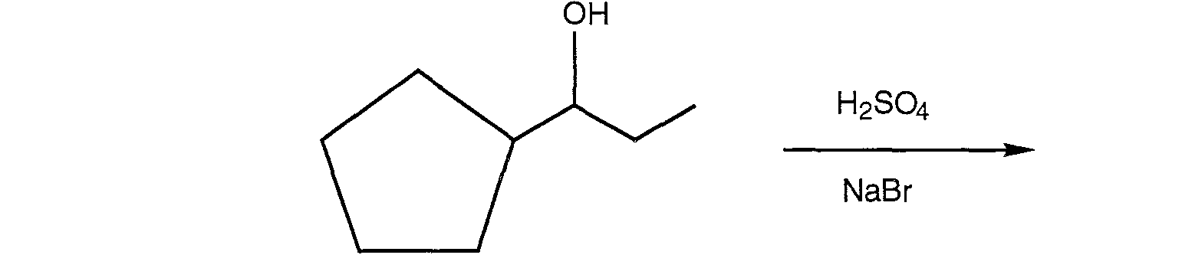

Please note that this is a secondary alcohol and as such the mechanisms should shift off being nearly completely SN2.

Consider other competing mechanisms .

**7-16**

H2O (solvent)

**heat**

**Specific Point Breakdown for Experiment 7**

Pre-lab Exercises - *20 points total*

1. **3** points
2. **3** points
3. **6** points
4. **8** points
5. Pre-lab write-up - *60 points total* Point breakdown:

**8** points for introduction

**4** points for balanced main reaction

**12** points for writing mechanisms for the synthesis. The students should use the arrow formalism and show all intermediates.

**8** points for the side reactions

**10** points for purification

**10** points for the completed table of reagents

**8** points for the completed table of products

1. Completed Lab Report - *50 points total*

**8** points for observations and data

**22** points for results

Breakdown:

**1** point for yield in grams

**2** points for yield in moles

**1** point for boiling range of product

**2** points for percent yield calculation

**2** points for reporting product appearance

**6** points for reporting GC retention times and identification of GC peaks

**4** points for calculation/reporting areas of GC peaks

**4** points for calculation/reporting percent purity of product

**20** points for conclusion Breakdown:

**8** points for explanation of deviation of yield from 100%

**6** points for summary of evidence supporting identity of product (GC, b.p., etc.)

**6** points for discussion of purity of product and possible sources of contamination

**7-17**

IV. Answers to Assigned Problems - *20 points total*

1. **10** points
2. **10** points

V. Product - *20 points total*

**8** points yield

**8** points purity

**4** points appearance

**7-18**