Experiment 25: Synthesis of Flutamide¹

Flutamide is an antiandrogen therapy that has long been used to treat prostate cancer. ² It is still used today! In preparation for this lab and for your own edification and enjoyment, you should read up on the web about flutamide, its use in cancer treatment and its mechanism of action.

The synthesis of flutamide is based on the adaptation ¹ of two literature synthesis ^{2,3} that are rooted in carboxylic acid derivative chemistry. The idea here is that if a carbonyl has a reasonable leaving group, a nucleophile can attack the carbonyl (delta plus site) and the pi electrons that are initially transferred to the oxygen, will flip back down and kick out the leaving group resulting in a net substitution and the carbonyl group is retained. These reactions are not reductions like the Grignard or organolithium reactions . This is demonstrated below in general and for flutamide, specifically. This can be studied in your text book in chapter 19 and 22 – you are encouraged to you use your index. You can also read any of the references given below .

Overall reaction:

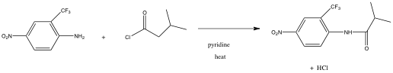

Not this is a net substitution.

Generalized reaction of carboxylic acid derivative with “good leaving group” and nucleophile:

The “flip”

Mechanism for Flutamide synthesis an example of carboxylic acid derivative chemistry.
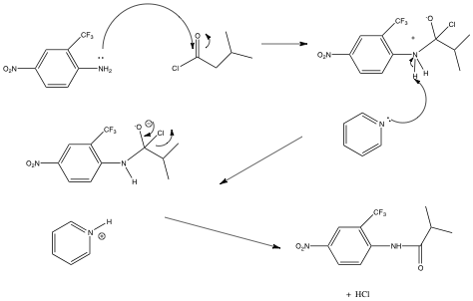

You might want to note that this chemistry is distinct from Grignard and organolithium chemistry or hydride type chemistry in that in these reactions, there was no leaving group and the pi electrons were transferred to the oxygen. They did not flip down, rather they stick on the oxygen resulting after protonation in an alcohol, resulting in a net reduction of the carbonyl. This is shown below and should be familiar.

The “stick”

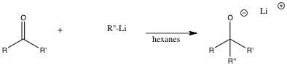

The reactions we have been doing the last few weeks demonstrate the way ketones and aldehydes behave in reactions . We have demonstrated two major pathways – the “stick” and the “flip” - these are not official terms. The other reaction you will do in this weeks lab (Experiment 26) will demonstrate a third major pathway which is conjugate additon. This reaction will be completed over two weeks and will overlap a bit with your project.

Procedure:

This reaction will be done in groups of four.

- Obtain a clean, dry 25 mL ehrlenmeyer. Weigh out 0.100 gram of 4-nitro-3-trifluoromethylaniline (write out this structure) and add this to the Ehrlenmeyer. Be extremely careful and only use the spatula provided. Do not waste this very expensive material. Put a small septum cap on the vial.

- Using only the labeled syringe provided, add 2 mL of pyridine through the septum cap to the same Erhlenmeyer. You should have a yellow solution at this point.

- Place the solution in an ice bath for five or ten minutes.

- Using only the labelled syringe provided, add about .07 mL of isobutyryl chloride (or other surprise acyl halide). Watch out, this reagent is a lachyrmator (why? Consider the reaction of the reagent with water in your eye). It must be measured in the hood. You will syringe this material dropwise into your reaction. The reaction frequently turns red at this point, but not always.

- The flask should be clamped above a 70 degree steam bath for thirty minutes with stirring.

- The reaction is added to 100 g of ice and stirred vigorously. After the ice melts you should have a pale, yellow solid. This solid can be isolated using micro vacuum filtration.

- The solid is recrystallized using micro techniques from toluene. What do I mean by this? Think about your recrystallization of your wittig product.

- Obtain a mass of the solid, its melting point and run its NMR. NMR time will begin at 3:30 PM.

The laboratory write up for this lab will be limited to the following.

The main reaction

The reaction mechanism. Though it is given, work through it, ask questions, just don’t copy it.

The mass of product obtained:

The percent yield: show calculation

The expected melting point: Give reference.

The melting point range. Yes it should be range.

The NMR and interpretation: Give reference for procedure.

A brief discussion of yield, purity and identity. This should be a one pager. NO MORE

This brief report will be turned into Dr. Nerz and she will grade it, one report per group. Dr Nerz grades all reports, papers, assignments for the rest of the course
All materials should be placed in her mailbox. Henceforth, one report per group.

The learning in these labs should come from the direct correlation with lecture, lab lectures should be studied and the background should be studied, the biology should be read and understood. You should gain much more about spectral interpretation. Note how references are done. You will do them this way in your final paper. It is expected that you will review procedures you have not done in a while, even if that means reviewing our videos.

See you in class an office hours.

Reerences

1. Ryan G. Stabile and Andrew P. Dicks
J. Chem. Educ., 2003, 80 (12), p 1439

2. http://en.wikipedia.org/wiki/Flutamide#Use_in_prostate_cancer

3. Baker, J. W.; Bachman, G. L.; Schumacher, I.; Roman, D. P.; Tharp, A. L. J. Med. Chem. 1967, 10, 93–95.

4. Neri, R. O.; Topliss, J. G. Substituted Anilides As Anti-An- drogens. U.S. Patent 4144270, March 13, 1979.

