Experiment 2  
General Safety Considerations

1. Beware of hot plates. A hot, hot plate looks just like a cold, hot plate
2. Use rubber grips to manipulate Erlenmeyers on hot plates. Once again, hot glassware looks just like cold glassware.
3. Be prepared for occasional splattering of hot liquids. Of course, it is a really good idea to use BOILING STONES, but just in case do not stick your face over the flasks.
4. Wear gloves and goggles at all times.
5. Do not touch chemicals (even with gloves). They are toxic and hazardous.
6. Never throw solid or liquid chemicals in the trash. When in doubt as to where to dispose of a chemical - ask your instructor.
7. Consult your instructor about major spills. If you come in contact with a chemical, flush the exposed area with cold water for fifteen minutes.

|  |  |  |
| --- | --- | --- |
| **Name**  **Chemistry 211-212 Investigative Experiments** | **TA Name:** | |
| **Experiment** # **2** | **Lab Day:** | |
| **Unknown** # | | |
| Section 1 (Pre-lab) | | (20 points) |
| Section 2 (Results) | | (39 points) |
| Section 3 (Post-lab questions) | | (66 points) |
| Quality of results | | (20 points) |
| TOTAL | | (145 points) |
| SCORE | | (percent) , |

**This is your report cover. Please fill it out and attach it to your pre-lab questions.**

# Experiment 2

**Recrystallization and Melting Point Determination: Yield vs. Purity\***

In this experiment, you will purify two crude samples of acetanilide by two different recrystallization procedures. The various methods of purification will be evaluated in terms of the relative quantity of acetanilide recovered versus the purity of the samples as demonstrated by melting point measurements. The weights and the melting points of the samples will be determined on your own time during the week following the experiment, allowing adequate time for the samples to dry.

The key to success in this experiment is control. The same amount of water must be used to dissolve each sample. Samples must be brought to the same temperature, for the same amount of time when dissolving. Each sample must be handled in the same sized glassware, etc. The only variable in this experiment should be the cooling temperature and the rate of cooling. The greater the variation in your handling of samples, the less likely it is that you will observe the expected trends in yield and melting points. Make your maximum effort to achieve control, but do not be dismayed if you do not observe the predicted trend in weights and melting points. As negative as this may sound, this experiment is tough for this early point in the semester. The experiment is designed for some failure to get you to thoroughly analyze each noted error. In this experiment, your explanation of your results is much more important than the results themselves. In preparation for this lab, read the following theory passages and answer the pre-lab questions that follow in your lab notebook.

"...for the idea one has long held of a person stops one's eyes and ears; my mother for three years did not notice the make-up with which one of her nieces used to paint her lips, any more than if it had been invisibly dissolved in a liquid; until the day when a streak too much ... brought about the phenomenon known as supersaturation; all the unseen make-up crystallized, and my mother, in the face of this sudden riot of colors, declared... that it was a scandal, and almost ceased relations with her niece."

Marcel Proust, *Remembrance of Things Past*   
contributed by Emmanuel d'Harcourt

*this experiment is adapted from Mosely, C. G. J. Chem. Ed. **1989**, 66, 12, *1063*

## Recrystallization Theory

### Yield

The amount of material recovered in a recrystallization is related to the temperature and the concentration of the recrystallization solution. The lower the temperature and the higher the concentration, the less soluble a solid will be. Why? Well, for a solid to go into solution, the individual molecules must replace the favorable interactions within the solid with similar solvent interactions. The types of interactions I am referring to here are those discussed in the section on Forces and Factors earlier in this manual. For example, one would expect t-butanol to dissolve in n-propanol. t-Butanol should be able to replace the solute-solute, dipole-dipole and Van der Waals forces found in the solid with attractive solute-solvent dipole-dipole and Van der Waals forces in solution. Most importantly, t-butanol would readily form extensive hydrogen bonds with n-propanol. Thus the expression, "like dissolves like" applies when considering solubility. Since the individual solvent-solute interactions are typically weaker (less complimentary) than the solute-solute interactions, it is often necessary for many solvent molecules to interact with a solute molecule to create a stable environment. In other words, quantity can make up for reduced quality.

The temperature factor is fairly straight forward also. At elevated temperatures, the solution has higher kinetic energy. The increased energy can compensate to some extent for a lack of complimentary interactions between solute and solvent molecules.

### Purity

The purity of recrystallized material obtained depends on several factors. 1) the original extent of contamination; 2) the relative solubilities of the desired compound vs. the contaminant; 3) the rate of crystallization; 4) the final temperature of the crystallization. Obviously, the more contamination one has, the more likely it is that contaminant will co-crystallize with the desired product, i.e., its concentration is higher. If the solubility of the contaminant is lower than that of the desired product, purification by recrystallization can be a problem. Usually though, the contaminant is in relatively small quantity and on the basis of higher concentration, the solubility limit of the desired compound is exceeded first. Interesting point in regard to today's experiment: salicylic acid is less soluble than acetanilide in water. How then is it possible to purify acetanilide using recrystallization?

The effects of the rate of cooling are very interesting. When a solution is cooled fast, the solids all come out of solution all at once. Rather than having a small number of crystals grow through a slow equilibrium process, a mass precipitation takes place leading to many very small nuclei upon which little growth occurs. For the same total mass, a group of small crystals has a larger total surface area than a group of larger crystals. Think about it. Does this make sense? The larger surface area leads to more contaminant adhering to crystal surface. Also, the rapid crystallization results in more contaminant being trapped inside the crystals. Again, crystallization is an equilibrium process. Contaminant molecules might be initially incorporated into a crystal, but would eventually leave the surface of the crystal and be replaced with the more abundant and complimentary desired molecules. In a precipitation, this exchange process can't occur as effectively. Finally, a very low absolute temperature results in more material crystallizing, both desired compound and contaminant.

# Melting Point Determination – Theory

The melting point (m.p.) of a substance is the temperature at which...

1. the solid and liquid phases have the same vapor pressure, and hence are in equilibrium with each other. The term vapor pressure refers to the "escaping tendency" of the solid into the gas phase and the "escaping tendency" of the liquid into the gas phase. It is important to realize that gas, solid and liquid are all in equilibrium during melting. If the two vapor pressures are the same, then the escaping tendency of solid into liquid and liquid into solid are the same. When this is stated, it does not mean that the solid and liquid have high vapor pressures at the melting temperature (which is much lower than the boiling point), it just means they have the same vapor pressure.

Obviously the main process during melting is the equilibrium between the solid and the liquid phases.

1. the energy of vibration (which increases with increasing temperature) is sufficient to overcome the forces that hold the crystal together (i.e., the lattice energy). Hence, solids having a strong crystal lattice have high melting points.
2. the solid liquefies.

Melting points of organic solids are **useful** to organic chemists because....

1. They (and other physical constants) aid in the recognition of such compounds. Extensive tables have been compiled, giving the melting points of different compounds and their derivatives (e.g., *Handbook of Chemistry & Physics* (CRC Publ. Co.); *Rappoport, Handbook of Tables for Organic Compound Identification* (CRC Publ. Co.); *Merck Index, NIST Website, Cambridge Website*, *WIKIPEDIA* (I am reluctant to admit I now obtain a lot of data from this site. etc.)
2. They aid in obtaining information about the **purity** of an organic compound. A pure organic compound has a "sharp" melting point, i.e., the entire sample melts at the same temperature or over a narrow range (0.1 or 0.2 degrees). Addition of an impurity has a two-fold effect: the m.p. is lowered and the m.p. range is broadened. Thus, the same compound that melts at 120.0° when pure might melt at 109-116° if impure. Both effects are usually increased by increased concentrations of impurities. In most cases, impurities **lower** the m.p. regardless of whether the m.p. of the impurity is higher or lower than the m.p. of the main substance.
3. They are useful in establishing the identity of a solid compound: **Mixed Melting Point Determination**. This technique is based on the fact, that one substance will lower the m.p. of another substance if mixed with it. A "mixture" of two specimens of the identical material, by contrast, shows no change in m.p. For example, assume that we have an unknown white powder, m.p. 121 °, which we suspect of being benzoic acid. Benzoic acid melts at 121°C, but so do a great many other organic compounds. We obtain from the stockroom a known sample of benzoic acid (an "authentic specimen"). Equal amounts of this known benzoic acid and our unknown are mixed intimately by grinding them together in a mortar. Then, we simultaneously determine the m.p.'s of the pure unknown substance, the pure authentic specimen, and of the mixture of the two. If all three have the same m.p., then the unknown is indeed benzoic acid (with a high degree of probability; there are a few exceptions). In that case, mixing unknown and authentic specimen amounted to mixing two different samples of the same material. The resulting "mixture" was not a mixture at all, but a pure substance, consisting of benzoic acid molecules only. So naturally, there was no change in m.p. By contrast, assume that the mixture of unknown substance and authentic specimen melting at 98-107 °C. This would prove conclusively, that the unknown substance was NOT benzoic acid.

Mixed melting points are very helpful in settling questions of identity in cases where an authentic specimen is available.

At this point, one might wonder why the melting point of a contaminated sample is depressed and broadened. To answer this question, first consider the following melting point composition diagram. This is a graphical representation of the melting behavior of various compositions of compound "X" with compound "Y". Such a diagram would be different for different pairs of compounds and would have to be constructed using experimental data. The given diagram is generic in nature.

First, some basic points to orient you with respect to the diagram. The x axis is percent composition and the y axis is temperature. Point "a" represents the melting point of pure X. Similarly, point "c" corresponds to the melting point of pure Y. Point "b" represents the so called eutectic point. The eutectic-point-has a corresponding eutectic composition (75:25, X:Y) and a eutectic temperature (point "g"). The eutectic temperature is the temperature at which the eutectic composition melts. The eutectic composition is special in that it is the combination in which each component is completely soluble in the other. At the eutectic temperature the two can form a solution without either being left over in the solid state. The eutectic mixture is also unique in that although it has a depressed m.p., it has a sharp melting point. 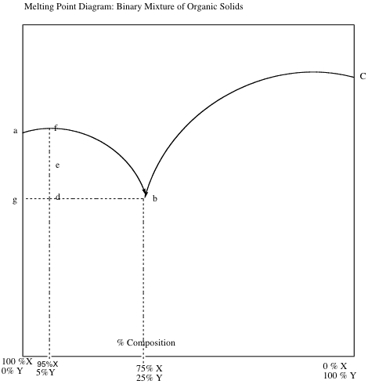

As mentioned previously, contamination usually results in melting point depression and broadening. The temperature range corresponding to points "d" through "f" represents the melting range of a 95:5, X:Y combination. The temperature range corresponding to points "e" through "f' represents the observed melting point range. Generally, binary mixtures of x and y melt from the eutectic temperature to the temperature corresponding to the upper curve intersection. Due to limitations in our ability to see the beginning of melting, the observed melting point ranges run from the temperature corresponding to the lower curve intersection through the temperature corresponding to the upper curve intersection. One last point, compositions to the right of the eutectic point can be thought of as X contaminating Y whereas, compositions to the left should be thought of as Y contaminating X.

Now getting back to why one normally observes broadening and depression in contaminated samples. Let us consider a 95:5, X:Y sample in the following discussion. At the very start of melting, it is probably easiest to think of melting point depression as being due to the contaminant Y molecules disrupting the interactions of the X molecules. The interactions in a crystalline lattice are normally very uniform and the molecules are packed tightly together. In most cases, the Y molecules would not fit as well into the lattice and would have weaker interactions. This disruption results in a reduced crystal Iattice energy and less heat being required to melt X.

When X begins to melt, it is best to think of the Y molecules dissolving into the melt according to their solubility in liquid X which is defined by the eutectic composition. Since we have an excess of X compared to a eutectic mixture (remember we are using a 95:5, X:Y mixture to explain melting), all of Y will dissolve in the melt leaving excess pure X in the solid state. The minor compound has a finite solubility in the major liquefied compound just like sugar in hot water. Remember, it takes a certain amount of hot water to dissolve a certain amount of sugar. If there is not enough water the remaining material does not dissolve. So these two compounds have a definite proportion that will dissolve at the elevated temperature and anything in excess of that, will be left in the solid state (the sugar laying in the bottom of the glass). This has to do again with the fact that it takes a certain number of interactions by the solvent to replace the interactions the solute has in the solid state. Think of the major compound as the solvent in this case and the minor compound as the solute. Once this situation is achieved , i.e., Xs X­l + Xl, one might wonder why the melting point doesn't just rise to the melting point of pure X. To understand why the melting point range is depressed overall, it is important to realize that the presence of Y molecules in X, reduces the ability of X to escape into the solid phase and the vapor phase. Does this make sense? Think about the surface of the liquid and how the Y molecules would block the X molecules or consider the fact that there are fewer X molecules at the surface ( per unit area) of the contaminated melt than at the surface of a pure liquid. Since melting is an equilibrium process, equilibrium must be maintained. This means that the solid X must have the same escaping tendency as the liquid while melting is occurring. The only way the solid can have a reduced vapor pressure is to be at lower temperature. The vapor pressure of a solid is more drastically reduced at lower temperature than the vapor pressure of a liquid. Thus, the escaping tendencies become equal at a temperature lower than the melting point of pure X. This is why the melting point continues to be depressed even after all of the Y is out of the crystalline lattice and dissolved in melted X. *Once again, the equilibrium temperature for melting* ***is*** *reduced due to the presence of* ***Y*** *in the* ***melt*** *which decreases the escaping tendency of the liquid into the solid and the solid into the gas phase. The only* ***way*** *the solid phase can match the reduced escaping tendency* ***is*** *at lowered temperature. Remember, melting is an equilibrium process*



Now what can we say about broadening? At the very beginning of melting a contaminated sample melts "sharp". All samples, regardless of composition start melting in the eutectic composition at the eutectic temperature. This should make some sense given the fact that the presence of Y in the solid state lowers the lattice energy and the eutectic composition defines solubility So our 95:5, X:Y sample will start melting at the eutectic temperature and it will melt in 75:25, X:Y composition as long as there is Y in the solid state. Again, the initial melting is the formation of a solution. The solution is defined by the solubility of one compound in the liquid state of the other. This occurs in very defined proportions based on the molecules interactions. This means that initially we have the following equilibrium: Xs + Ys. Xl+ Yl. Please note that the proportions in the melt do not change as long there is Y in the solid state. Melting is initially sharp because there is no change in the escaping tendency of the liquid (the proportions in the melt are constant at the eutectic point – or as long as they can form a solution) and therefore, the temperature of the solid need not change.



As mentioned previously, however, there is an excess of solid X compared to the eutectic composition. So we run out of solid Y before we run out of solid X. At this point , we have   
Xs Xl+ Yl and the melting stalls at the corresponding equilibrium



temperature. This is because if more Xs melts, the composition of the melt changes, i.e., it is enriched in X with respect to Y. This would increase the escaping tendency of   
XI  Xs because the solid's escaping tendency is not large enough to accommodate such a change in the liquid state. Basically at the interface between the solid and liquid, there is a greater proportion of Xl in the liquid state. Think of it as thought the Xl  is more exposed to the solid state because of this greater proportion – more is pressing up against the solid. When I say more here, I mean more compared with the original eutectic composition. This increased composition can’t be sustained at the low eutectic temperature so the excess liquid deposits back on the solid. To continue melting then, the solid must absorb heat . If the solid's temperature is increased, the escaping tendency of Xs  Xl is increased and an increased percentage of X in the liquid state can be accommodated. When melting is occurring, all of the energy provided is used to separate the molecules. When melting stalls as described here, the heat is absorbed by the sample which increases the solid's escaping tendency that that of the contaminated liquid and melting continues. Of course, the melting will stall continuously as the composition of the melt is continuously enriched in X. The sample must constantly absorb heat during the melting process. This is why a broad melting range is observed for a contaminated sample. The high end of the melting point range is still reduced relative to pure X because the melt has Y in it, which reduced the escaping tendency of liquid X relative to pure liquid X.



**Prelab Questions**

1. Fill in the blanks on the following flow chart (next page) generally describing this week's recrystallization. Insert an answer at each arrow. You may use the flow charts at the beginning of nearly every experiment in this book for guidance. (3 points)

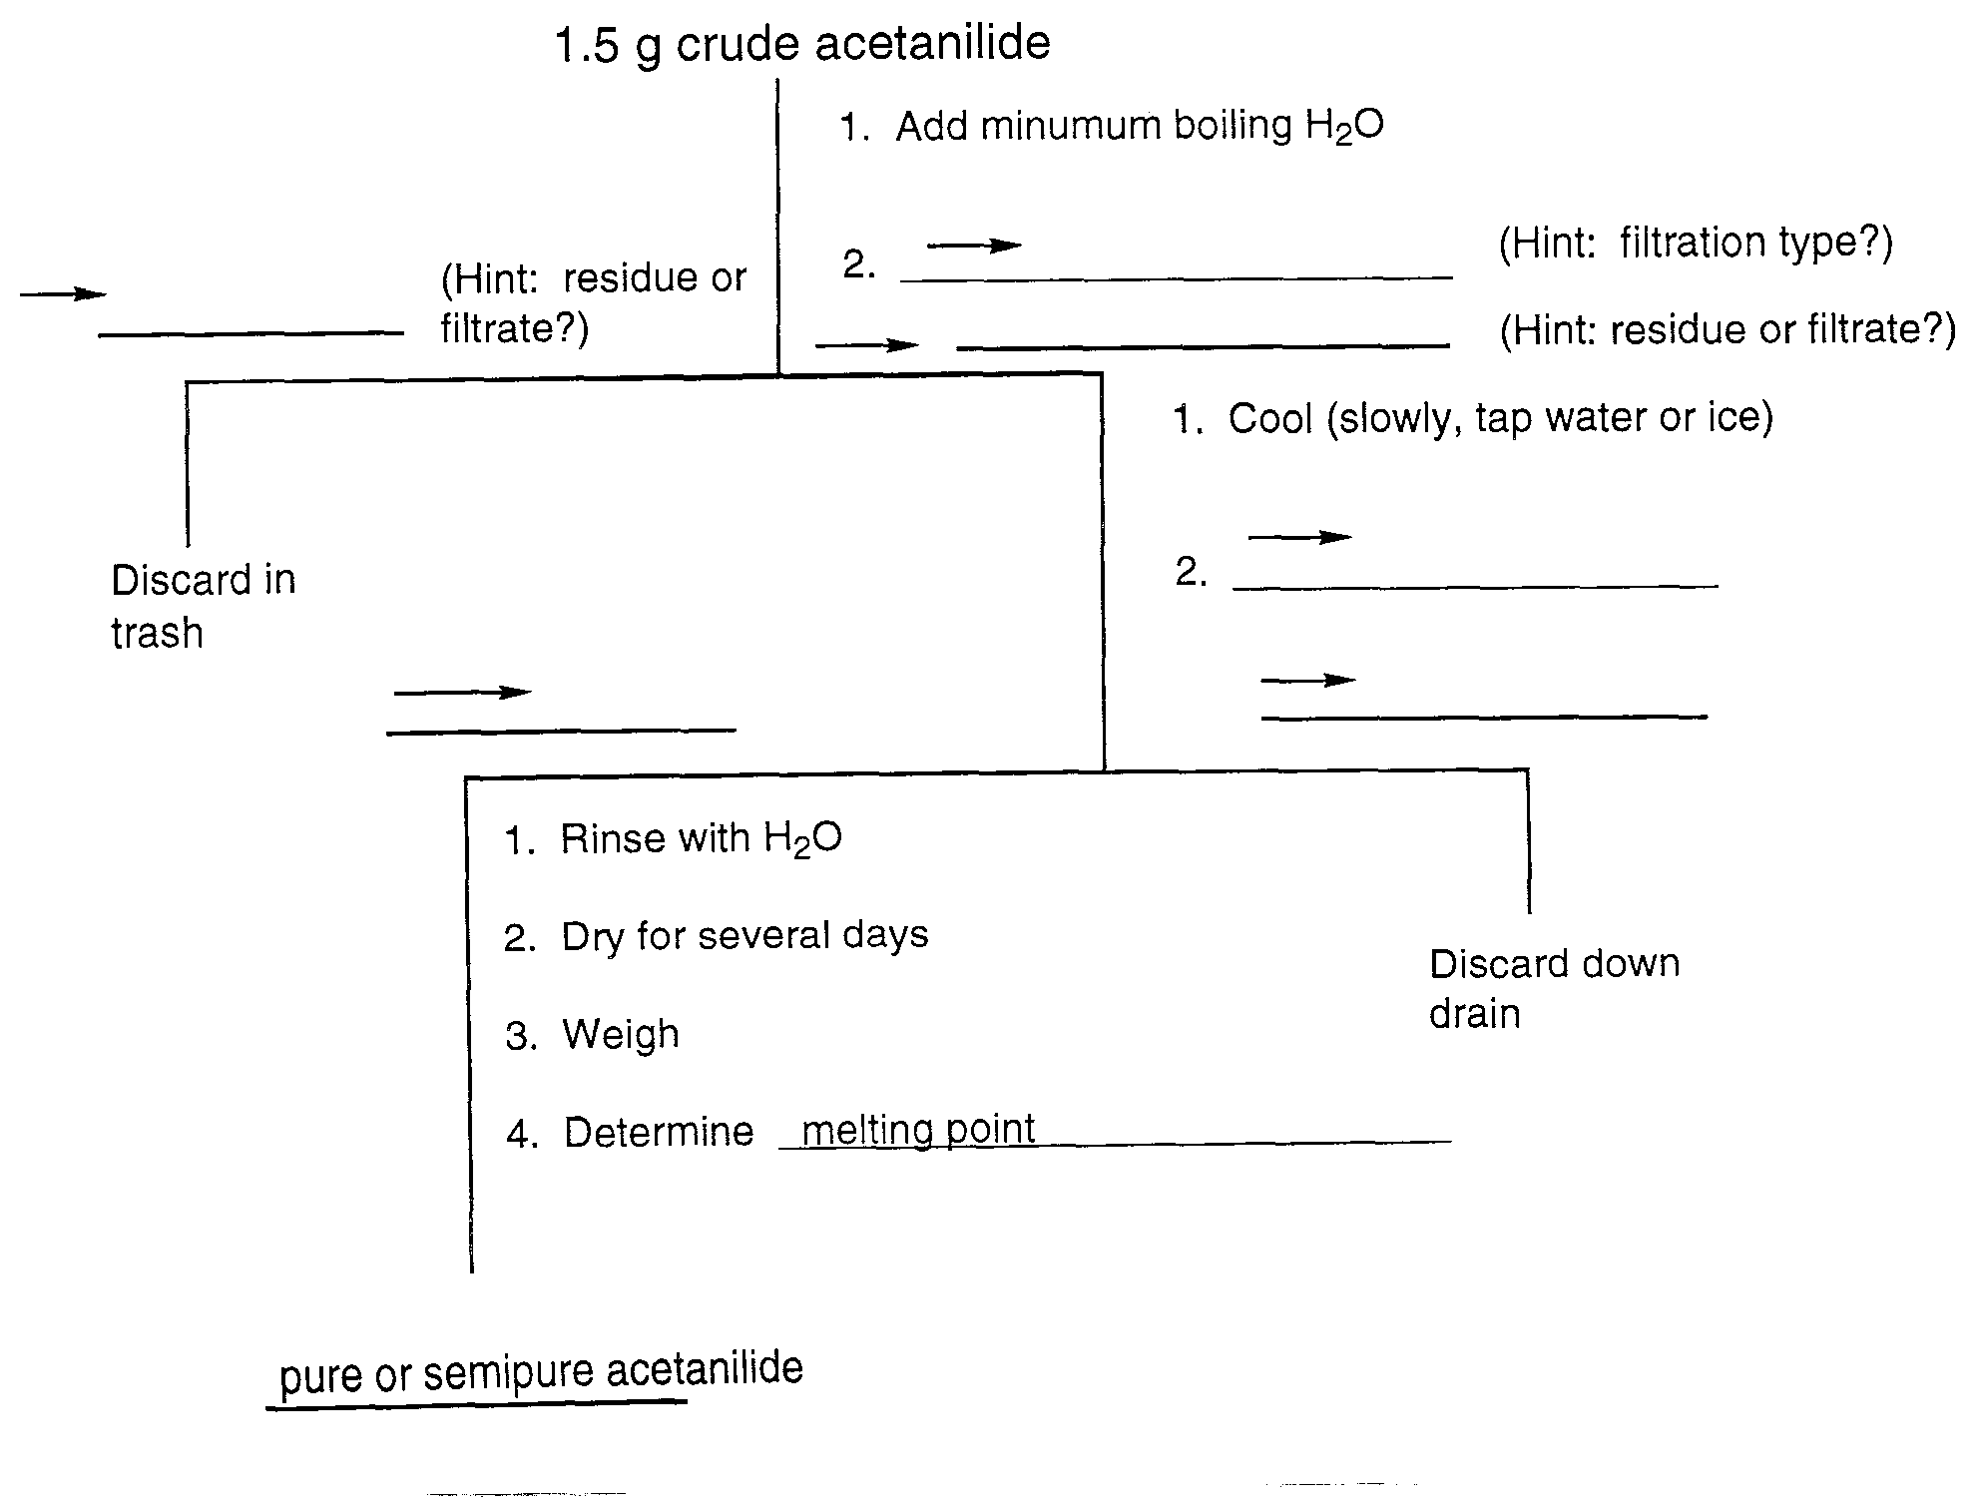**[INSERT FLOW CHART HERE]**

2 a. Which sample do you believe will be obtained in highest yield? Explain. (2.5 points)

b. Which sample do you believe will be obtained in highest purity? Explain. (2.5 points)

1. List the major errors that could contribute to unexpected results (results that are inconsistent with your above predictions about yield and purity) in this experiment. Explain how each error will influence the yield and melting point trends. Be very, very specific about the errors and realize there are at more than six places where you could lose control and upset the

results. (12 points)

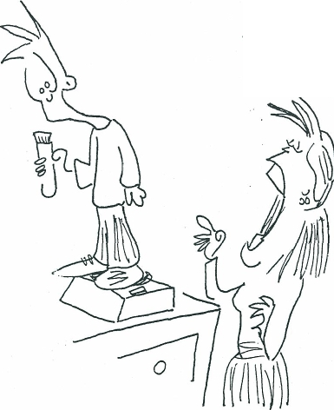

*I think there’s a better way to tare that …*

By Jack Maypole

## Procedure

1. WEEK 1
   1. Obtain from your T.A. or instructor a 3.0 g sample of crude acetanilide. For your information, the acetanilide has been artificially contaminated with salicylic acid and charcoal.
   2. Mix the crude material well and divide it into 2, 1.5 g samples. Each 1.5 g sample should be weighed directly into a 125 mL Erlenmeyer flask **using the normal balances that weigh to .01 gram.** Label the flasks A and B, respectively.
   3. Bring approximately 200 mL of distilled water to boiling. Add this in increments to the two crude acetanilide samples until all the soluble components are dissolved. Bring the solutions to boiling after each addition. Do not boil any sample for an extended period of time. Why? Keep track of the quantity of boiling H2O needed to dissolve the acetanilide. It should be **very similar** for both samples and in the range 50-60 mL. NOTE: The approach outlined here involves dissolving both samples at once. This is fine for some students, but more often than not better control is achieved by the novice working with one sample at a time.
   4. Hot gravity filter flask A to remove insoluble impurities. Please study the apparatus diagram following this lab. Allow the filtrate of flask A to cool slowly to room temperature. Occasionally stir the solution to promote crystallization.
   5. While filtrate A is cooling, hot gravity filter flask B. Immediately place the filtrate in an ice water bath. Occasionally, stir and scratch the sides of the flask to promote crystallization and prevent the formation of an oil. Allow this flask to get as cold as possible (e.g. 0 - 5°C internal temperature).
   6. Allow each of the samples to stand at their respective minimum temperatures for five minutes.
   7. Collect each acetanilide sample by vacuum filtration. Once again, study the apparatus diagram following this lab. Rinse sample A with 5 mL of room temperature distilled water, sample B with 5 mL ice cold, distilled water.
   8. Allow the two acetanilide samples to dry until the next laboratory period.
   9. If you have time and the machines are available, move on to part "B" of the procedure and measure the melting points of pure acetanilide, 95:5 acetanilide:salicylic acid and 85:15 acetanilide to salicylic acid.
2. WEEK FOLLOWING EXPERIMENT
   1. Allow at least two days for the A & B samples to dry.
   2. Weigh the two acetanilide samples.
   3. Carefully determine the melting points of all of the following samples.
      1. pure acetanilide (can be done during first week of lab)
      2. 95% acetanilide, 5% salicylic acid mixture (can be done during first week)
      3. 85% acetanilide, 15% salicylic acid (can be done during first week)
      4. sample A
      5. sample B

**General Comments on Making Melting Point Measurements**

1. Densely pack the capillaries (using the packing tubes) to a maximum height of 2 mm. Use a ruler if you have no sense of the metric system.
2. Measure the melting points of the knowns first and the unknowns (samples A and B) second. The melting points should be done in groups of two or three.
3. Generally, the samples will shrink and expel recrystallization solvent first (sweat). Then they will begin to melt. You can either first record the temperature at which liquid is first observed at the bottom of the tube or the shrinkage/sweat point. The liquid at the bottom temperature is more traditional, but this is difficult to judge in some cases. The second temperature to be recorded is the temperature at which all the solid is liquid.
4. Set the mel-temp voltages to a level that provides a temperature change of 2°/minute. To determine this, consult the voltage charts provided at the melting point stations.
5. Efficiency Tips: The mel-temps do not have to cool to room temperature to start a new measurement. They must, however, be cooled to approximately ten degrees below the projected starting melting temperature of the next sample. When the block temperature is excessively low, the voltage can be set higher than desired until you get within ten degrees of the projected melting temperature to speed up the heating of the block. Once you are within ten degrees, however, reset the voltage to an appropriate value.
6. Your instructor will be delighted to help you with any questions/problems you may have. Please bother her! Don't beat your head against the wall!

### Your Lab Report

Please note that during the academic year, this lab is completed as a conference. This means that you would sign up (SEE SIGN UP SHEETS OUTSIDE YOUR INSTRUCTORS DOOR) for a thirty minute conference during which your results will be discussed and compared with your classmates. The theory of the lab will also be discussed during this conference. Though this conference is generally a “low pressure” experience it is important that you have read over the lab and have all your data with you. This means you must come to the conference with all melting points and all masses obtained in the experiment. You will be able to sign up over the course of two months.

During the summer school session and at other designated times the following post-lab writeup should be completed. Again, though this is difficult to believe, if you are taking the course during the fall semester of the normal academic year, you will not complete a postlab write up, you will simply have a conference.

**Post-Lab write up for Summer School and Other Designated times:**

Once again, this will not be a normal investigative report. Only include the sections listed below. Do your best this week to improve the style of your writing and the level of detail included in your answers. Try also to avoid repeating yourself and try to write in the third person, passive.

* 1. The answers to the pre-lab questions. (20 points)
  2. All raw and processed data. (33 points)

**6** points recorded crude masses of 2 samples

**6** points for recorded volumes of boiling solvents needed to dissolve each sample

**6** points for recorded masses of purified samples

**6** points for recorded melting point ranges for two purified samples 6 points for calculation of percent recovery for two samples

**9** points for recorded melting point ranges for standard samples

* 1. Answers to the following questions: (66 points)
     1. In your own words, explain how melting point broadening and depression occur. (8 points)
     2. Explain how each of the impurities was removed during the procedure. (4 points)
     3. What is the structure of acetanilide? Give a medical use for acetanilide (Hint: Merck Index or google it). (4 points)
     4. In terms of intermolecular interactions, try to account for the differences in melting point between salicylic acid and acetanilide. (6 points)
     5. Where did you realistically lose material in each of your two recrystallizations. Where do you think the biggest losses occurred? (10 points)
     6. Can you now add new errors to the control errors you outlined in your pre-lab? If so, list the additional errors. (8 points)
     7. Was your data consistent with what you predicted? If not, explain why your data deviated from the prediction. (10 points)
     8. Using your standards, estimate the purity of each of your experimental samples. What are the most likely (if any) contaminants to your samples? (8 points)
     9. Now that you have carried out at number of melting point analyses. What are the most significant errors that can be introduced while carrying out these measurements? (8 points)