**Chemistry 211-212 Cover Sheet**

|  |  |
| --- | --- |
| **Name: __________________________** | **TA Name: ________________________** |
| **Experiment # 11a** |  |
| Page 1 Worksheet (Pre-lab) | ______________ ( 20 Points) |
| Page 2 Worksheet | ______________ ( 28 Points) |
| Page 3 Worksheet | ______________ ( 30 Points) |
| Page 4 Worksheet | ______________ ( 22 Points) |
| Page 5 Worksheet | ______________ ( 36 Points) |
| Quality of results | ______________ ( 20 Points) |
| Total | ______________ (146 Points) |
| Score | ______________ % (percent) |

**This is your report cover. Please fill this form out and attach it to your form.**

**Experiment 11a and b  
General Safety Considerations**

1. AlCl3 reacts violently with H2O liberating HCI gas. Be careful when you open AICI3 bottle (keep your nose out of it). Make sure you tightly cap the bottle when you are finished. Do not allow your AICI3 to sit around exposed to the atmosphere. It will react with the atmospheric H2O and deactivate. When you measure out the AICI3 you should immediately transfer it into a very dry round-bottom (the reaction flask) and immediately cover the aluminum chloride with the p-xylene. The p-xylene will create a barrier to the atmospheric H20. Generally, wear gloves and goggles. In the event of a spill, **consult** your instructor immediately.
2. p-Xylene, 1-bromobutane and 1-bromopropane are irritants and toxic. Take all the normal precautions to avoid exposure. Keep the chemicals in the hood as much as possible. Wear gloves and goggles. In the event of a major spill, consult your instructor. if you come in contact with these substances, flush the exposed area for fifteen minutes with cold water.

# Experiment 11a Flow Chart

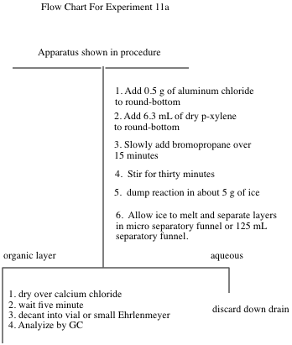

**Experiment 11a**

**Aromatic Substitution: Friedel-Crafts Alkylation**

“Science repulses the indefinite.”

Claude Bernard (1813-78), *Introduction L’Etude de la Medecine Experimentale* (1865)

In preparation for this investigation, carefully study the Friedel-Crafts Reaction in your textbook, view any provided youtube videos and answer the pre-lab questions on the form that follows the procedures in this lab.

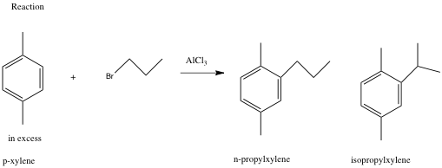

This exercise is **an** excellent example of the kind of experiments that are done in order to investigate the mechanism of a reaction. Your objectives are to carry out the Friedel-Crafts alkylation of p-xylene with 1-bromopropane and analyze the products by GC. The expected products are n-propyl-p-xylene and iso-propyl-p-xylene. You will determine the ratio of these products by GC. The extent of isomerization of the alkyl group from n-propyl to iso-propyl gives information on the rate of rearrangement versus the rate of alkylation. You will compare that information with the ratio of products found in the alkylation of benzene.

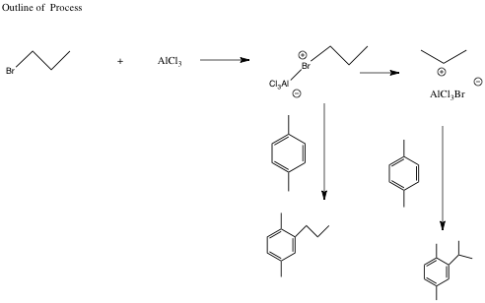

A. Procedure:

1. Set up the apparatus shown on the top of the next page in the hood using drierite in the curved adapter. The method to pack the drying tube (the curved adapter filled with drierite) is as follows. Wearing gloves, put a small amount of glass wool in the curved adapter. Add enough drierite using a spatula to nearly fill the tube. Then place a small piece of glass wool at the end of the tube. If the drierite is dry, the colored drierite will be blue. If it has absorbed significant water, it will take on a reddish/pink color. If the drierite becomes wet during the reaction, it should be replaced. In building your apparatus, you should be using your 14/20 micro glassware and the round-bottom should be a 25 mL round-bottom. Set a magnetic stirrer under the round-bottomed flask. Take the addition funnel to the hood and add to it 0.025 mole of 1- bromopropane. Stopper the funnel with an appropriate septum cap and reconnect it to the apparatus. Place a small magnetic stirring bar in the 25 mL roundbottom flask and bring it and a small septum cap to the hood. Place 0.5 g of aluminum chloride in the flask and immediately cover it with 6.3 mL of dry p-xylene (the point is to minimize exposure of AlCl3 to moisture in the air). Quickly reconnect the flask to the apparatus.
2. With the stirrer on, add the 1-bromopropane dropwise (1 drop or less per second – you may have to close the stopcock occasionally). After addition is complete (about 15 minutes), allow the mixture to react an additional 30 minutes.

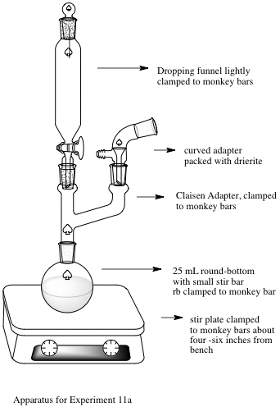

**Experiment 11 Apparatus**

1. Pour the mixture into a 50 mL beaker containing about 5 g of ice . Stir until the ice has melted, then transfer to a 25 or 30-mL separatory funnel, separate the layers, and discard the aqueous layer. Dry the organic layer over anhydrous CaCl2 for about 5 minutes.
2. Filter or decant the solution into a small Ehrlenmeyer flask or vial and carry out a preliminary GC analysis of the solution. If you have sensitivity problems with the GC, adjustment of the concentration of the sample may be necessary. Please see your instructor if you are having trouble with the GC.

B. Lab Report

A standard lab report will not be required for this lab. If you complete the attached form, you have finished the lab write-up.



**Experiment 11  
Form Write-up**

Name:________________________________Exp. name:

T.A. Name Date:

**I.** Pre-lab Exercises

1. Why is it essential to use a gas trap and to work in the hood while carrying out this experiment? (5 points)
2. Why is a drying tube used in this experiment? (5 points)
3. What side reaction will occur if the glassware used is not dry? (5 points) . D. Why is an excess of p-xylene used in this experiment? (5 points)

II. Experiment and Results

1. Attach the required GC to the back of the report. Assign a structure to each peak on the GC. (10 points)
2. Report the ratio of products in percent form for the reaction excluding unreacted p-xylene. ( 8 points)

III, Discussion/ Conclusions

A. Discussion of Rate of Rearrangement vs. Rate of Substitution. This is very important and should include structures and include the overall mechanism of the reaction. ( 20 points)

. Error Analysis. Focus on errors that might alter the ratio of products. (10 points)

IV. Post-lab Questions

A. Analyze the 1H NMR spectrum of n-propyl p-xylene and isopropyl p-xylene. Copies of the spectra will be provided to you at lab lecture. (10 points)

B. Write a complete mechanism (arrow formalism, resonance structures) explaining the formation of the two products. (8 points)

C. Why was the reaction mixture poured on ice at the end of the reaction, Write equations to describe any chemistry occurring in this step. (4 points)

D. Approximately what ratio of rearranged to unrearranged products do you expect if toluene (methyl benzene) is subjected to the reaction carried out in this lab? (8 points)

E. Given the fact that the reaction you just did is kinetically controlled, what do you suppose might happen if the temperature of the reaction was raised enough to cause equilibration. (8 points)

V. Quality of Results (20 points)