Chemistry 211-212  Name  Experiment #  Page 1 Worksheet Page 2 Worksheet Page 3 Worksheet Page 4 Worksheet Page 5 Worksheet Quality of results |  |  |  |  | Form Report  TA Name:
 | 10
 |  | TOTAL SCORE |  |  | (14 points)  (10 points)  (28 points) (24 points) (12 points)  (20 points)  (108 points) (percent)

This is your report cover. Please fill this form out and attach it to your form.

Experiment 10
General Safety Considerations
- All of the materials used in this experiment should be considered to be irritants and toxic. As always, you should wear gloves and goggles and work in the hood continuously. in the event of a major spill, consult your instructor. In the event of skin contact, flush the exposed area with large amounts of cold water for at least fifteen minutes.
- All the materials used in this experiment are flammable. Be especially careful with the ethylacetate/hexane recrystallization system. Do not overheat! Use an Erlenmeyer, not a beaker in the recrystallization.
- Maleic anhydride is water sensitive as are the anhydride Diels-Alder products.
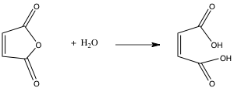
Obviously, to the extent that your reaction is exposed to water, you will obtain undesired products.

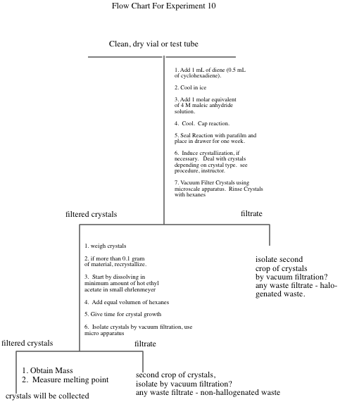
Experiment 10
The DieIs-Alder Reaction

The DieIs-Alder reaction is a very important reaction from a synthetic perspective as it results in the formation of a six membered ring in one step with high stereospecifity (what does this mean? – one stereoisomer gives rise to one stereoisomer or no more than a pair of enantiomers). The formation of six membered rings is very important because six membered rings are abundant in natural products and generally, in molecules that are useful to man. As such, the Diels-Alder it is a Nobel prize winning reaction and was recently voted by organic chemists as one of their three favorite reactions (I concur!!). The Diels-Alder has very specific stereochemical aspects. To explore the stereochemistry of the DieIs-Alder reaction, you will carry out one of three microscale reactions. Each of the possible reactions has more than one stereoisomeric product possible. The reactions to be carried out are outlined in the following scheme.
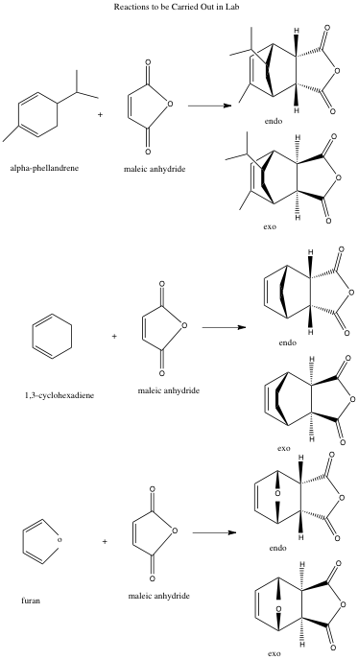
As indicated in the scheme, exo and endo stereoisomers are possible from each reaction. Exo and endo isomers are really cis/trans or geometric isomers (why?). Since alpha-phellandrene is chiral and we will be using only R-alpha-phellandrene. There are actually two exo and two endo products possible from the first reaction outlined. In addition to the synthetic experience gained in this reaction, we will be

interested in finding out which stereoisomer(s) predominates in each reaction, The exo and endo products can readily be distinguished on the basis of their melting points.
Exo/endo stereochemistries and the chiral Diels-Alder reaction are quite difficult for beginners to understand. The following passages should begin to help you make sense of it, but you really should build models, ask questions and think about it a few times. It will also be covered in lab lecture, in regular lecture and in youtube videos.
The terms exo and endo are relevant for the products of Diels-Alder reactions involving a substituted diene and a substituted dienophile. A ring diene can be viewed as a substituted diene. Exo and endo arise from the diene and dienophile approaching each other from different orientations. For example, consider the reaction of 1,3-cyclohexadiene with maleic anhydride.
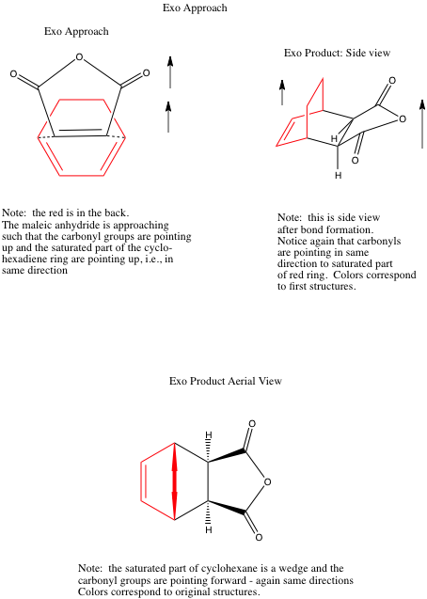
In the so called exo approach (outlined above), the substituents (the saturated part of the ring and the carbonyls are on top of each other) are stacked on top of each other. This approach results in the anhydride functional group being cis to the bridge-head (the saturated part of the ring) on the newly formed cyclohexene ring. These orientations will be covered extensively in laboratory lecture and in youtube videos. Different models and explanations will be used so don’t panic when looking at these pictures. Also your textbook is very useful on this topic. You will be reading the book in conjunction with lecture. Do not worry, we will get through it!

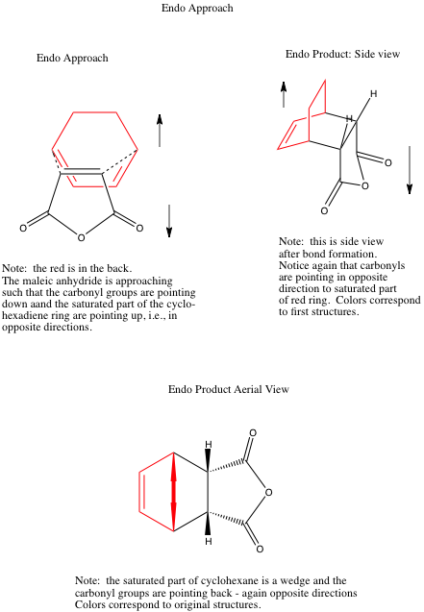
In the endo approach, the substituents (the saturated part of the ring and the carbonyls) are pointing in opposite directions leading to the bridge-head and anhydride functional group being trans with respect to each other on the newly formed Diels-Alder ring. These orientations have to do with the way you stack the dienophile with respect to the diene using your models. If the substituents on the diene (the rest of the ring) are pointing opposite to the carbonyls – it is an endo approach, if they are in the same direction – it is exo. Try stacking the two starting materials with your models.
Generally, under kinetic conditions (to be discussed in lab lecture and youtube, kinetic conditions are those that produce the kinetic product which is the product that is formed the fastest or has the lowest energy transition state), the endo transition state is favored. It is believed that there are favorable interactions between the pi systems (p orbitals) on the carbonyl groups of the dienophile and the pi system on the diene. These interactions are not possible in the exo approach. In some reactions, the exo is the thermodynamic product (the product that is the lowest in energy regardless of the energy of the transition state) and the conditions of the reaction are such that the thermodynamic product dominates. Note: room temperature could be sufficient for a thermodynamic reaction, though most Diels-Alder Reactions are conducted under conditions that result in the kinetic (endo) product. Again, play with your models to try to see what is different about the two following approaches.
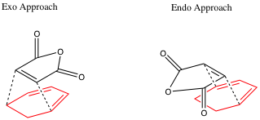

If you think about it, there are really two endo approaches. For example, I could also write an endo approach as follows. In other words, I can stack the dienophile with the carbonyls opposite to the saturated part of the ring from the top or the bottom of the diene. I now have the maleic anhydride molecule oriented the same left to right, but it is now approaching the opposite face of the diene. Try the two approaches with your models.
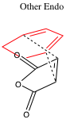
With achiral molecules, the two exo (or endo) approaches lead to the same products. When chiral molecules are used such as alpha-phellandrene, the two approaches
become different. Consider the endo attack of maleic anhydride on chiral alpha-phellandrene. This involves orienting the maleic anhydride so that the carbonyls are to the right and the saturated part of the molecule is to the left opposite = endo, but considering the stack with the maleic anhydride on the top far from the isopropyl vs. the stack with the maleic anhydride on the bottom far from the isopropyl. Which is easier from a steric or Van der Waals perspective?
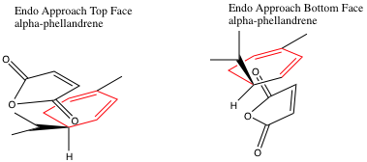

Obviously, the two approaches lead to two different endo products. Likewise, there are two different exo approaches leading to two different exo products. Can you model these with your model kit. These stacks would both have the saturated and carbonyls on the same side.
In preparation for this experiment, study the Diels-Alder reaction in your textbook, listen carefully to all lectures and study any youtubes provided and answer the following questions on your form.
Prelab Assignment
- Draw the structures of the exo products not drawn in the scheme on page 10-4.
- If you were a maleic anhydride molecule and you were attacking the alpha-phellandrene molecule shown directly above, which face would you prefer to attack and why?
- What is the stereochemical relationship between the two endo products fromthe Diels-Alder reaction of alpha-phellandrene and maleic anhydride (hint: are they enantiomers or diastereomers)?

- Given the information that (-)-alpha-phellandrene has the "R" absolute configuration, write a three dimensional structure representing the absolute configuration of (-)-alpha-phellandrene.
- Which solvent are the Diels-Alder products shown above most soluble in, hexane or ethyl acetate?
Week I. Three Microscale Diels Alder Reactions (Adapted from Pickering,
M. J. Chem. Ed. 1990, 67, 524.)
1. You will be assigned one of the three proposed reactions to do. Depending on which you were assigned, add 1 mL of (-)-alpha-phellandrene, 1.0 mL of furan or 0.5 mL of 1 ,3-cyclohexadiene to a clean, dry labeled test tube or vial. Cool the container containing the diene in ice. Use your graduated cylinder to measure these quantities.
- Add equimolar quantities of 4M maleic anhydride solution (note this is a solution of maleic anhydrice in dichloromethane – it is not pure maleic anhydride – these means there are 4 moles of maleic anhydride in every liter of solution) to each to the three tubes using the provided syringes with blunt needles. You should have done the necessary calculations before coming to lab (Hint: Figure out how many moles of diene you are using. Then figure out how many mL of maleic anhydride solution contains that number of moles.) Please be careful to cap the maleic anhydride solution and do not allow your reaction to sit uncovered for any length of time as the dichloromethane evaporates very, very quickly.
- Cork the tube (or cap the vial) and seal them with parafilm. Allow it to sit in your locker until next week, Note: Students (everyone) always love parafilm. As much as you will want to use it for everything, realize that it can't be put in direct contact with organic vapors. Why?
- Use the extra time in this lab to do the worksheet on Diels-Alder and oxidation provided by Dr. Nerz. You can also use the time to ask questions if you had trouble with your pre-lab. You can work in groups.
Week II. Purification and Identification of the Microscale Product
- Examine your test tube or vial. If it contains a reasonable quantity of crystals it can be vacuum filtered directly. If it does not contain crystals or there are very few, the solution is probably supersaturated. To induce crystallization, dip a glass stirring rod into the tube and remove it. Upon allowing the glass stir rod to dry, you will observe crystals on the rod. Dip the rod into the tube and crystallization should be instantaneous. Collect any resulting crystals by vacuum filtration.
If you have problems getting crystals in this manner, try allowing your solution to sit open in an ice bath in the hood for a half hour or more. If you don't get crystals in this time period or two, consult your instructor. More extreme measures may be necessary. Please consult your instructor or TA.
- Your product can be further purified by recrystallization from hexane/ethyl acetate systems as described below. After crystals form, collect your product by vacuum filtration. Rinse the crystals with a small amount of hexanes ( why hexanes?).
a) Weigh the product from your reaction If you have more than 0.10 gram of a product, recrystallization is feasible. Set aside enough of the "crude" product to do two melting points and subject the balance of the material to recrystallization.

b) If you have less than 0.2 g of material, consult your instructor about quantities of solvent to use. Otherwise, use your 25 mL Erlenmeyer for
this recrystallization. Vials and beakers are inappropriate for recrystallization. Why? To recrystallize, add 1 mL of ethyl acetate to your product and gently heat it to boiling on the hot plate. If the solid doesn't dissolve, add an additional 1 mL of ethyl acetate, etc. It is important to be very careful not to over heat and not to over-dilute. When dissolved, remove the solution from the hot plate and add a quantity of hexanes equal to the quantity ethyl acetate added. Allow the flask to cool slowly. If crystallization does not occur, add another 1 mL of hexanes. Often a 1:1 ratio of ethyl acetate: hexanes (volume:volume) works best. What is going on in this recrystallization. We will try to discuss this with you while you are working.
3. Allow your product to dry for several days on a tared watch glass, Then weigh it and measure its melting point. Melting point data for the three microscale products is given below. Don't worry about the names of these complicated compounds. You do not need to look them up. Molecular weights can be calculated using the periodic table. If purity is unsatisfactory, you may want to recrystallize it againMelting points for microsca!e reaction
endo product exo product
alpha-(-)-(R)-phellandrene product 126°C (not available)
furan product 80-81°C 114°C
1,3-cyclohexadiene product 147°C 157-158°C

Lab Report
This lab report will be considerably abridged. Answer the pre and post-lab questions in the spaces provided on the form. Only include the material requested on the form/worksheet, THIS IS NOT A STANDARD PREPARATIVE REPORT.
11. In addition to answering the pre-lab questions that appear earlier in this lab, and filling out all the data sections and data analysis sections in the form, answer the following questions in the spaces provided on the form (part 11).
- Explain what is going on the recrystallization of the Diels-Alder product, i.e.,
what happens with the addition of each solvent? Why are two solvents being used? Would water be appropriate as a solvent in this recrystallization?
- If (±)-alpha-phellandrene had been used, how many major products would have been obtained from reaction with maleic anhydride? Write the structures of these products.
- Using a transition state argument, explain why endo products generally predominate over exo products.
- Predict the major products for the following Diels-Alder reactions. If you believe the reaction is unfeasible, simply write no reaction and explain briefly.
***************************************************************************************
The following are some helpful tips to help you in writing Diels-Alder Reactions, they are not further questions. They should help you in answering question d.
HINT: When determining the products of complex Diets-Alder reactions it really helps to number the six atoms involved in the Diets-Alder reaction and then do the reaction just with those atoms. At the end, just reattach the substituents in the original positions. In other words, the Diels-Alder reaction is always the same. The substituents can make it hard to envision, but the substituents should be regarded as simply along for the ride.

e.g.
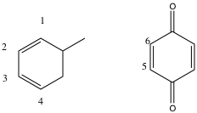

Ignoring the substituents, it becomes:
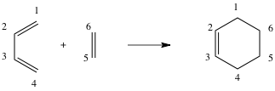
Then, say to yourself.... "carbon 1 is also related to four through the bridgehead... therefore, add the bridgehead
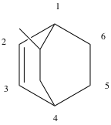
"carbon 5 and 6 are also related through the carbonyl containing bridgehead"
therefore

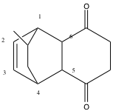

************************************************************************************

d. continued (these are the d. questions, use the above to help get the products).

1.

2.
(low concentration = unlikely to encounter another molecule like itself)
- Write suitable starting materials leading to the following Diel's-Alder products. (Hint: the numbering method giving in part "d" works here as well. Just use it in reverse.)
1,
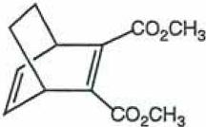
2.
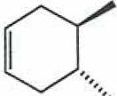
f. Using the arrow formalism, write a reasonable mechanism explaining the hydrolysis of maleic anhydride into maleic acid. Hint: think about how water might attack maleic acid. Where are the delta plus and delta plus sight in the anyydride and the water. Remember negative attacks positive. If you are really struggling, consult your textbook regarding ester or acid anhydride hydrolysis or just google it.

3. Use the extra time in this lab to plan your thermodynamic Friedel-Crafts for next week. It is expected you will have a plan when you leave lab this week. Go over the Friedel-Crafts reaction and what you will be doing to create a Friedel-Crafts that is under thermodynamic control. Your lecture today will delve into this. Please consult your text and any provided youtubes.

+++++++++++++++++++++++++++++++++++++++++++++++++++++++++++++
It happens also in chemistry as in architecture that 'beautiful" edifices, that is, symmetrical and simple, are also the most sturdy: in short, the same thing happens with molecules as with the cupolas of cathedrals or the arches of bridges. And it is also possible that the explanation is neither remote nor metaphysical: to say "beautiful" is to say "desirable," and ever since man has built he has wanted to build at the smallest expense and in the most durable fashion, and the aesthetic enjoyment he experiences when contemplating his work comes afterward.
Primo Levi, The Periodic Table

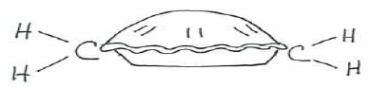
-- A Pie Bond by Liza Donlon and Heather Campbell

Do the poet and scientist not work analogously? Both are willing to waste effort. To be hard on himself is one of the main strengths of each. Each is attentive to clues, each must narrow the choice, must strive for precision.
-- Marianne Craig Moore Bryn Mawr College
Class of 1909

Experiment 10 Worksheet
Name: ______________________________ Date: _______________________

T.A’s Name: ______________________________________________________

- Prelab Questions:
  - 4 points

  - 3 points

  - 3 points

  - 4 points

  - 6 points

- Observations Made During Lab (6 points):

- Appearance of Product; (2 points)

- Yield of Product in Grams: (2 points)

- Yield of Product in Moles: (2 points)

- Theoretical Yield of Product in Moles or Grams: (4 points)

- Percent Yield Calculation: (2 points)

- Summary of Evidence Supporting product Identity: (10 points)

- Explanation of Deviation of Yield from 100%: (10 points)

- Evaluation of Purity of Product Naming Possible Contaminants: (10 points)

- Postlab Questions
  - 8 points

  - 4 points

  - 2 points

  - 1) 2 points

2) 2 points

  - 1) 2 points

2) 2 points

  - 4 points

- Quality of Results – 20 points total (for TAs only)
10 points for quality of product
5 points for purity of product
5 points for appearance of product

