# Experiment 1 Fractional Distillation and Gas Chromatography General Safety Considerations

**Please Note:**

As indicated in your initial laboratory lectures, the first three lab reports will not follow the investigative or preparative report formats described in the introductory pages of this lab manual. For these labs, you will only turn in what is requested in the individual lab. Pre-lab questions must be completed before lab.

1. The liquids are flammable! No flames in lab!
2. Study glassware for cracks before beginning. If you find any, show the damaged glassware to your instructor.
3. Make sure that the joints are flush in the distilling apparatus and that the vacuum duct is unobstructed.
4. Secure H2O hoses with wire. Keep the water pressure moderate to low.
5. Do not discard distillate or pot residue (exception: the spent cloves can go in the trash) in sinks, garbage cans or general waste containers (large red cans in waste hood). Used cyclohexane and toluene should be poured into the appropriately labeled containers in the dispensing hoods. These liquids will be used again next year.
6. Never distill to dryness.
7. Unless instructed otherwise, heat conservatively.
8. Build your still several inches off the top of the bench.
9. Do not plug your powermite directly into a "normal" socket. It must be plugged into a "powermite" (also called variac, step control).
10. Cyclohexane, toluene, and methylene chloride are irritants and toxic. Methylene chloride is particularly irritating when it is trapped under a ring or a glove. Avoid contact with these substances by wearing gloves and goggles. Keep these compounds in the hood as much as possible. In the event of a significant spill, consult your instructor. If you suspect you have gotten any of these substances on your skin , flush the exposed area with cold water for fifteen minutes. Occasionally, an organic compound will seep through the nitrite gloves. Remember, gloves are just a primary barrier. If you feel any itching or burning under your gloves, take the gloves off and flush the exposed area for fifteen minutes with cold water.

|  |  |  |  |
| --- | --- | --- | --- |
| **Chemistry 211-212** | Investigative Experiments | | |
| **Name** | | **TA Name:** | |
| **Experiment** # **1** | | **Lab Day:** | |
| **Unknown** # | | | |
| Section 1 (Pre-lab) | | | (25 points) |
| Section 2 (Results) | | | (56 points) |
| Section 3 (Post-lab questions) | | | (70 points) |
| Quality of results | | | (20 points) |
| TOTAL | | | (171 points) |
| SCORE | | | (percent) |

**This is your report cover. Please fill it out and attach it to your prelab questions.**

**Eugenol Isolation Flow Chart**

Place Ground Cloves in 100 mL Flask  
with 40 mL of water

Steam Distill

Distillate

Pot Residue

Dispose of liquids down drain, cloves in trash

Extract with 8 mL CH2Cl2

Aqueous layer

Extract with 8 mL CH2Cl2

Extract with 8 mL CH2Cl2

Organic layer

Aqueous layer

Organic layer

Aqueous layer

Discard down drain

# The Basics of Distillation

Flush down drain

Residue

Rotovap to dryness

subject to olfactory analysis

Filtrate

Dry over NaSO4 Gravity Filter

Combine organic layer

Distillation most commonly refers to the process of vaporizing a liquid in one vessel and then recondensing it in another vessel. It is usually used to separate one compound from another (others), but it can also be used to help to identify a compound because distillation is a reasonable way to determine the boiling point of a liquid.

For a distillation to occur at a reasonable rate, the compound in question must have a high vapor pressure. This is the same as saying it should have a low boiling point or that it should be volatile (N.B. volatile does not mean explosive). Vapor pressure refers to the rate at which molecules escape from a liquid (solid). If there is a high rate of escape or the vapor from the compound is exerting a lot of pressure against the atmosphere, then the compound has a high vapor pressure. Compounds that have a high vapor pressure at room temperature can often be detected by olfactory analysis. Diethyl ether has a high vapor pressure as does naphthalene (moth balls).

Boiling is not a necessary requirement for distillation, but it certainly accelerates the process. What is boiling? A liquid is boiling when the vapor pressure of the liquid equals that of the atmosphere giving the liquid the maximum rate of escape into the vapor phase. If a liquid has a low boiling point, its intermolecular forces are low and less energy is needed for molecules to escape into the vapor phase at their maximum rate. So if a liquid has a low boiling point, it has a higher vapor pressure at any temperature, but the maximum rate of escape can be achieved at a relatively low temperature. It is important to realize that like other phase changes, boiling is an equilibrium process. When a liquid is boiling the escaping tendency of the liquid into the gas phase equals that of the gas into the liquid phase.

As mentioned previously, boiling is not a necessary requirement for distillation, but it is usually done to speed up the collection of liquids in the receiver. The preceding discussion also opens up the idea that there is a relationship between the atmospheric pressure and the boiling point. That is, the more the atmosphere weighs down on the liquid, the greater the energy input must be to have those molecules escape at a high rate. On a high pressure day, our boiling points will go up and on a low pressure day they will go down. Now you may be a little more interested in what your weather person has to say each morning!

The relationship between atmospheric pressure and boiling point tells us that if we could reduce the atmospheric pressure in a controlled way, we could intentionally reduce the boiling point of a liquid. In principle, if the atmospheric pressure is lowered enough, liquids will boil at or below room temperature. In the laboratory, the atmospheric pressure is typically reduced by attaching a vacuum line to the distillation apparatus. In a couple of weeks you will use the rotary evaporators in the lab. These are really reduced pressure distillation apparatus. Reduced pressure distillation or vacuum distillation is useful when one wants to rapidly remove a volatile solvent from nonvolatile compounds, when minimal heating is important due to the thermal instability of a compound or when a compound has such a high boiling point that atmospheric distillation is not feasible.

First we will consider distillation as a purification method. There are fundamentally two different types of distillation that will be used routinely in this course, simple and fractional distillation. The simple distillation apparatus is shown below. Simple distillation is used in less critical separations of compounds. It can be used to separate a non-volatile solid from a liquid. For example, if one had a solution of sodium chloride in water, one could use this apparatus to distill the water from the sodium chloride. Of course, the sodium chloride would remain in the pot and the water would end up in the receiver. Simple distillation can sometimes be used to separate two volatile liquids provided that the two liquids have vastly different boiling points, say more than 50 degrees.

Simple distillation is a reasonable way to determine boiling point. One can load the pot with a pure unknown liquid and very carefully and slowly distill it. The still head temperature will quickly level off. The range of temperatures observed at the still head during the temperature plateau is the boiling range of the unknown. Since the boiling point is related to the structure of the compound, knowing the boiling point can be useful in identifying the compound.



The fractional distillation apparatus is shown below. Obviously, the only difference in the set up is the insertion of a column between the still pot and the still head. It doesn't look like much, but that column can make the world of difference in a separation depending on its construction and size. Fractional distillation can be used for very critical separations. In principle, one could separate any two liquids provided there is a difference in boiling point. Again though, the ability to separate is totally dependent on the equipment and the way the distillation is carried out. To understand this better this better some basic comprehension of distillation theory is needed.

**Fractional Distillation Apparatus**



For a fractional distillation of two volatile liquids to be successful, it is imperative that the two liquids form a solution and that the solution behave in an ideal fashion, i.e., when the liquids vaporize, the vapor phase must be enriched in the more volatile component. It should make sense that if one component has a lower boiling point than the other it should have weaker forces and should have a higher vapor pressure. This being the case, the molecules should leave the solution at a higher overall rate thus producing an enrichment.

It is also important to realize that when heating (or even at room temperature) both types of molecules are vaporizing simultaneously, though hopefully one escapes in greater quantity than the other. This is one of the most common misconceptions about purification through distillation - that the more volatile component just jumps off the surface of the solution, leaving the less volatile component behind. This would be true of water in a solution of sodium, but not true at all of a solution of two reasonably volatile liquids.

The total vapor pressure of a binary solution of two volatile components A and B can be described as follows.

Pr XAP°A +XBP°B

The above equation is a combination of Raoult's law and Dalton's law of partial pressures. What it is basically saying is that the total pressure of the system is the result of the partial pressure of each of the components making up the solution. The partial pressures in turn depend on the amount of each component and the vapor pressure of the individual component. So if one had an equal quantity of diethyl ether (b.p. 34.6°C) and hexane (b.p. 69°C), diethyl ether molecules would be escaping at a higher rate. If one had unequal quantities of two compounds having the same vapor pressures, then the one in larger quantity would be escaping at a higher rate.

To understand enrichment or how purification occurs better let us first consider a simple distillation. In theory, a simple distillation apparatus has one theoretical plate. A theoretical plate is one enrichment. An enrichment is a single vaporization resulting in an enhancement of the more volatile component relative to the less volatile component. Suppose we have a 50:50 mixture of two compounds A and B, respectively. Lets say that when this solution is initially vaporized it is enriched to 60:40, A:B. If the simple distillation apparatus truly has only one enrichment then the material collected in the receiver of the distillation apparatus would be 60:40. If further enrichment is desired, one could take the 60:40 material and add it to a clean still pot and re-distill it. Upon re-vaporization it might go to 70:30, A:B and so on until the desired purity is achieved. Obviously this is not a very efficient way to go about a purification. Please note that I am making the enrichment increments up in a convenient manner for the sake of simplicity. As you will see later, enrichments do not occur in such even increments.

Switching to a fractional distillation set up will greatly improve matters. In the fractional distillation apparatus a column has been added. The column can vary quite a bit with regard to its structure. Generally, columns are better if they are longer and packed with a material that provides a large surface area. What does the column do? Well consider the hypothetical 50:50, A:B mixture again. This mixture is heated to boiling and it vaporizes. Lets assume it is enriched to 60:40, A:B as with the simple distillation. At this point, it is important to think about the boiling point of this solution. If you could take the thermometer from the still head and lower it into the distillation pot, you would find that the boiling point of the 50:50 mixture lies between the boiling point of the two individual compounds. What is the boiling point of the vaporized, enriched 60:40 material like? It should be closer to the boiling point of pure A which means the boiling point should be lower than that of the 50:50 mixture. Being lower boiling means that the enriched vapor phase condenses at a lower temperature. It rises up and hits a cooler part of the apparatus and condenses. It then starts to flow back into the pot. But being lower boiling means that it doesn't have to flow as low to revaporize. It is important at this point to realize that the column has a temperature gradient. The set up is hottest at the bottom and is cooler as one approaches the still head. So the 60:40 flows not quite as low and revaporizes again to say 70:30. The 70:30 has an even lower boiling point so it travels higher in the column before recondensing. It also does not have to drop as low to revaporize. Its boiling point is lower. The condensation/revaporization cycles continue over and over again until hopefully nearly pure material is obtained at the top of the column. This would be the material that is first condensed and collected in the receiver.

From the above discussion it is evident that a surface on which the liquid can condense is important. If the column were very short and/or not packed with a material to provide this surface, fewer condensation/ vaporization cycles would occur and the material initially condensed into the receiver would not be as pure. As mentioned previously another term for one of these enrichment cycles is a theoretical plate. The more efficient a column is the shorter the height equivalent of a theoretical plate (HETP). A very efficient column has many theoretical plates. You will discover through our investigations that our lab columns do not have many theoretical plates.

Once again it must be emphasized that the increments of enrichment given above were quite ridiculous and were created to make the explanation of enrichment a bit simpler to follow. The following vapor phase composition diagram describes the quantitative aspects of enrichment better. In reading this diagram realize that the X axis corresponds to the percent composition of the solution. The Y axis corresponds to temperature in degrees Celsius. There are actually two curves on the diagram. The upper, convex curve corresponds to the vapor phase composition curve. The lower, concave cure corresponds the liquid phase composition. The point "A" given at the far left of the curve corresponds to the boiling point of pure A. The point `B' given at the far right is the boiling point of pure B. Now how does the curve work? Suppose You have a 50:50 solution of A:B. The 50:50, A:B is vaporized. If it is an ideal solution, it will become enriched in the vapor phase with respect to A. To find out the vapor phase composition extend a line from 50:50 A:B on the X axis to the liquid phase composition curve. Then draw a perpendicular until you intersect the vapor phase composition curve. Then draw a perpendicular down to the percentages on the X axis. This ratio, 82:18, A:B is the vapor phase composition. The process we just went through is the equivalent of one enrichment, plate or simple distillation.

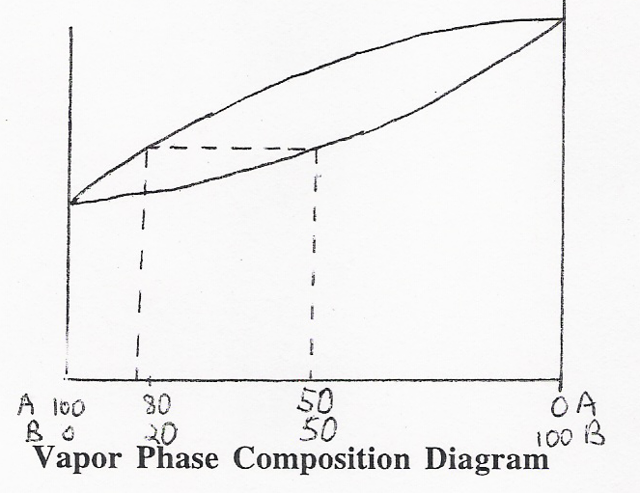

Now to get the idea of what happens in a fractional distillation, this process would be repeated over and over, one step for each plate in the column. So the enriched, material would recondense and then revaporize. Upon revaporization it would enrich to as indicated on the graph and so on. You will note that enrichments get progressively smaller as one approaches pure "A". This is significant for you in lab this week because if you start with an unknown that is richer in cyclohexane your overall enrichment will be less that someone who starts with a sample that is richer in toluene even though there may be no variation in technique or equipment from you to your neighbor.

It is important to recognize that other factors influence the purity of a sample. Generally speaking, the faster a distillation is done, the cruder the material will be at the top of the column. For a distillation to go faster, one normally increases the rate of heating. With greater heat input, the column ends up being hotter and has less of a temperature gradient. With a smaller temperature gradient, fewer enrichments occur. To understand this better think about a theoretical distillation occurring over a column having the exact same temperature as the still pot. The material in the pot would vaporize and enrich, but the column would be so hot that the material would not recondense until it hit the condenser. Without multiple recondensations in the column, little enrichment will occur. Even though a slower distillation is better, we usually have to compromise a bit so that we can finish these labs in a reasonable amount of time. So though your purity will not be its absolute best, stick to the prescribed distillation rates so that you will not have to stay overnight to finish the lab. We usually aim for a rate of one drop per second going into the receiver. If your rate is less than that at any time during the procedure increase the voltage. If it is more, decrease the voltage.

There are a few more terms you should absorb at this point. The term **holdup** refers to the amount of liquid that must be left in the distillation apparatus to avoid distilling to complete dryness. We usually stop a distillation when the liquid level is just above the boiling stones. Stopping at this point avoids the possible explosion of peroxides that may have formed during vigorous heating. When this is done liquid is left in the pot, but also on every surface in the still. Holdup is a source of material loss in a distillation. The term **throughput** refers to the rate at which one distills. The higher the throughput, the lower the purity.

# Boiling Stones

Boiling stones are normally small chips of carbon (like charcoal). The chips are porous and have many long, circuitous channels passing through their structures. The channels have a large total surface area. Trapped in these channels are many smallgas molecules. One of the problems in heating a liquid is that is may become superheated (heated above its boiling point, but unable to boil because of the lack of nucleation sites). Superheated liquids have a tendency to vaporize suddenly and violently, releasing a large amount of gas all at once. The very large bubble or bubbles of gas are released explosively pushing the hot liquid out of the container. This is called bumping. Why would this be a problem in distillation (or in cooking – it can happen in a microwave!)? Not only do the long circuitous channels provide surfaces for smaller bubbles to form (nucleation sites), but the gasses already trapped in the channels are nucleation sites and facilitate the movement of the high energy liquid molecules into the gas phase via these pre-existing gasses. The evolution of these small bubbles makes for even, safe boiling. Can boiling stones be reused?

# The Basics of Gas Chromatography

To understand gas chromatography it is helpful to review what you learned about paper chromatography or ion chromatography. If you have not tried paper chromatography, simply apply a dot of black marker to the bottom of a paper towel strip. Dip the paper into water and allow the water to rise by capillary action. You will see the “block ink” separate into is constituent components. Gas Chromatography has many similarities to that process. In paper chromatography there is a stationary and a mobile phase. The components to be separated are applied to the bottom of the paper and the separation relies on the differences in affinity of the compounds being separated for the stationary phase and the mobile phase. The differences in affinity can be related to the polarity of the molecules in most cases. In paper chromatography, the stationary phase is the water that adheres to the cellulose or the paper. The mobile phase was the solvent that rises up the paper during the elution by capillary action. If a given component to be separated has a higher affinity for the solvent (i.e., is more soluble) system it will migrate higher. If a component has a relatively higher affinity for the stationary phase it will end up closer to the origin. Summing up, differences in polarity translate into differences in affinity which result in a separation. It is important to recognize that the separation is an equilibrium process. The molecules being separated are continuously moving back and forth between the two phases. The more soluble the molecules are in the mobile phase, the more time they will spend there and the farther they will move. Please try to avoid the natural inclination to believe that most soluble molecules leap off the stationary phase into the mobile phase and fly up the paper, never returning to the stationary phase and leaving the less soluble molecules behind. This ideal situation would only happen in cases where the differences in solubility are extreme.

Gas chromatography involves the same elements as paper chromatography. There is a stationary phase. In our GC's this is a compound called carbowax that is packed inside the GC column. The mobile phase is the helium gas which is continuously passing through the column. The greater the affinity of a compound being separated for the mobile phase the faster it will come off the column. Once again, successful separation is dependent on the compounds being separated having different affinities for the phases. Please refer to the following diagram of a GC for the ensuing discussion.

Injection Port Column Detector Automatic Integrator

During your first week in lab, you will discover that GC samples are applied to the column using a syringe. Now what happens after you inject the sample? The injection port is very hot and because of this, the sample is first vaporized. For your information, the injection port is usually set at a temperature that is much higher than the boiling point of the compounds being separated. The helium stream from the tank is sweeping through this port and it picks up whatever has vaporized and carries it into the GC column. The GC column is just a long stainless steel tube that is usually coiled to fit in the oven. Remember, GC relies on molecules spending some of their time in the gas phase so like the injection port, the column is heated. The column temperature is set closer to the boiling point of the compounds being separated. Often times, the temperature is a little below the boiling points. Under these conditions, a substantial number of the molecules to be separated are in the gas phase, but molecules are also continuously condensing.

Let us use the GC separation of cyclohexane (b.p. 80 0C) and toluene (b.p. 110 0C) as an example. These components will be in the samples you will separate by GC during the first two weeks of lab. When you inject a solution of cyclohexane and toluene into the GC it is vaporized and swept into the column as described above. In the cooler column, molecules condense and revaporize continuously. Like paper chromatography, there is an equilibrium between the two phases. When molecules enter the gas phase, they are swept up in the helium stream and make *progress along the column. When they condense* they *stop* moving. Considering the two compounds involved in our separation, which is likely to spend more time in the vapor phase? Cyclohexane of course. Cyclohexane has a boiling point of 800C where Toluene has a b.p. of 110°C. If the column temperature is set at approximately 95 °C, more cyclohexane will reside in the vapor phase at any given time than toluene. If the cyclohexane is spending more time in the vapor phase it will move along more quickly than the toluene and will eventually separate provided the column is long enough. This is the same as saying that the cyclohexane will reach the end of the column first .

Enhancing the separation is the presence of the stationary phase. Though there are a wide variety of stationary phases one can use, in our GC's you will work almost exclusively with Carbowax. Carbowax is a polar material that become a viscous oil upon heating. When thinking about how the stationary phase might enhance the separation, one needs to think about solubility. Which of the two compounds being used in our example is more polar? Toluene is the correct answer. Its polarity is in part responsible for its elevated boiling point. Being more polar (cyclohexane is not polar) it should be more soluble in the polar stationary phase. This fact, increases the likelihood that toluene will spend more time in the stationary phase. The interaction with the stationary phase slows it down more with respect to the cyclohexane, increasing the separation.

Upon reaching the end of the column, the molecules enter the detector. There are several types of detectors one can obtain, but our instruments all have thermal conductivity detectors. These detectors measure any changes in the ability of the gas stream to conduct heat. When changes occur, they are registered by the automatic integrators as a peak. When anything other than helium passes through the detector, conductivity is altered and a peak is observed.

Our instruments are hooked up to computers that will show the peaks, the times of the peaks, and it will also give you the percentage area of each peak read. This is useful information for you because it gives you an indication of the purity of your sample. Realize that you won't really know what the areas correspond to, i.e., do they correspond to weight percent, volume percent or mole percent? Since the detector responds differently to different compounds, you will not be able to directly translate the numbers into any sort of units without calibrating the instrument. Calibration requires more time than we normally have available in lab. Regardless, the numbers are very useful in the sense that they will provide you in a relative sense the purity of your sample.

The print out will also give you numbers called retention times. The retention time is the time it takes for the sample to go from the injection port to the detector. The shorter the retention time, the lower its affinity was for the stationary phase. This usually means that the compound had a low boiling point and a low polarity. The retention time is analogous to the Rf values calculated in paper and thin layer chromatography. In principle, it is a constant and can be used in conjunction with other information to help identify a compound. As with Rf values in paper chromatography, it is very difficult to duplicate retention times. For a compound to give identical retention times on two different GC analyses, they must be run under identical conditions, i.e., the temperatures, the column, and the helium pressure must all be identical. It is very difficult to duplicate conditions. You should not be shocked if your retention times do not match those derived from a different machine with seemingly similar parameters. The best way to begin to get a handle on the identity of a compound giving a peak in a GC is to run standards. How would this be done in GC? To answer this think about your paper chromatography experiment done in general chemistry.

# Steam Distillation

A new technique that arises in this experiment is that of steam distillation. When you isolate the clove oil (eugenol and acetyl eugenol) from cloves, you will not have a solution. Instead, you will have two layers. Unlike the distillation of a solution (e.g., cyclohexane/toluene), these two layers will behave as distinct entities and there will be no dependence on how much of each species is present. The total pressure of the pot liquids can be defined by the following equation.

|  |  |  |  |
| --- | --- | --- | --- |
| PT = | PA° | + | PB° |
| Total vapor pressure | Vapor pressure pf pure “A” |  | Vapor pressure of pure “B” |

Notice there are no mole fraction terms in the equation. This means that if you have lots of water or just a little it will make the same contribution to the vapor pressure. What will happen when you distill? The mixture will heat up and eventually boil. **Please recall that boiling occurs when the pot liquids have a vapor pressure equal to the external pressure. In steam distillation, the pressures of the two components must add up to 760 torr.** Throughout the heating process, water and clove oil molecules will escape in proportion to their respective vapor pressures at the distilling temperature. Since water has a significantly lower boiling point than eugenol or acetyl eugenol, a much greater proportion of water molecules will be vaporizing at any time during the distillation. Even though the components of clove oil have low vapor pressures, they are volatile enough to vaporize to some extent and a small amount will lift off with the water molecules. Since the water and organic components are not interacting with each other, no enrichment occurs and they will co-distill at a single temperature until all of one component is completely distilled over. Normally, steam distillations are carried out with a large excess of water. When all the organic component has been distilled, pure water begins to distill. How is this situation reflected in the appearance of the liquid and in the still head temperature?

While the steam distillation is occurring, the boiling point of the two together will be lower than the boiling point of the more volatile component. Why? At the end of the distillation, you will have two layers in the receiver which can be separated.

A helpful relationship when considering steam distillation in a theoretical sense is the ideal gas law, PV = nRT, where P = pressure, V = volume, n = moles, R = the gas constant and T = temperature. It is important to remember that all of these parameters refer to gaseous molecules. Since distillation involves the expansion of a liquid into a gas in a fixed volume (the still), the gas law can be useful in predicting the amount of water needed to complete a steam distillation or to figure out the proportion in which the organic and aqueous layers will co-distill. To gain a more practical expression, take the ratio of a gas law written for the gaseous water and one written for the organic gas. If this is done, one obtains the following expression.

(PH2O) (VH2O) = (nH2O)R(TH2O)

(Porg) (Vorg) (norg) R(Torg)

Fortunately, several of the terms in the above expression cancel. The volumes cancel because both gases occupy the same space, i.e., the still. The temperature terms cancel because the two components are co-distilling at the same temperature. The R terms obviously cancel.

The equation therefore reduces to:

PH2O = nH2O

Porg norg

This simple equation sums up steam distillation because it demonstrates that the amount of water obtained *is directly* proportional to the vapor pressure of water at the distillation temperature. The same is true of the organic component . Therefore, if the organic component has a higher boiling point than the aqueous component, it will contribute fewer molecules to the overall push against the atmosphere. Nonetheless, the two components are working together. You can think of the system as being like two people trying to push a broken down car. The weaker person may not be contributing much, but is still reducing the work for the stronger person. Because the organic is there, the water does not have to push as hard against atmosphere and this is why the overall temperature is the below the boiling point of pure water.

Now with all this sophisticated theory stated, why is steam distillation useful? You might wonder why you would not just take the cloves and press the oil out of them or extract the cloves directly with an organic solvent such as methylene chloride or ether. The problem with pressing the oil out (and this can be done) is that the yield is very low. You might be able to imagine that much of the material would get caught up in the solid matrix that constitutes most of the mass of the cloves. The problem with a direct organic extraction is that many other nonvolatile organic components of the clove would also dissolve in the solvent resulting in a much more complex mixture. Purification would become time consuming and material would lost with each added step. With steam distillation, only the volatile components are collected and they can be isolated exhaustively if enough water is used.

In summary, steam distillation is an ideal way to separate volatile compounds from nonvolatile contaminants in high yield. For these reasons it has been used extensively in the isolation of natural products.

# Fragrance Chemistry

Odorants are small, volatile molecules that constantly evaporate from their sources in low concentrations and are perceived by chemical sensors (smell and taste receptors in our nose and mouths). It date, approximately 1000 different types of molecular receptors have been identified in the human nose allowing for humans to differentiate as many as 10,000 different odorants. In mammals it is believed that there are approximately 1000 genes responsible for olefaction. In humans, the number is considerably smaller, approximately 374 3,4,5,6

Please read the following for a good summary of the proposed mechanisms of olefaction  
<http://www.nationmaster.com/encyclopedia/Olfaction.>

The following pages give the structures and corresponding names of a number of scented compounds. You can test the scents of most of these compounds while you are in this lab this week. Though conservative scent testing of compounds is encouraged this week, the general lab rule is to avoid organic fumes.

The most important concept to get out of this reading and your experience in lab is that scent is related to structure. Though we may not totally understand what it is about the structure that causes us to perceive a particular scent or the exact biochemistry of the sensation, we can say conclusively that the different scents of compounds are due to specific aspects of their structure. In fact, all physical properties are directly related to molecular structure. It is particularly noteworthy that the tow carvones have such different scents!!!! These compounds are know as enantiomers. They are very closely related, differing only in the spatial arrangement of two groups. Specifically, they are mirror images of one another. The fact that one carvone has a spearmint scent and the other has a caraway scent indicates that smell receptors have a handedness or chirality2 associated with them and are able to chemically distinguish such subtly different structures. This is really a profoundly important concept. When you think of your body as a collection of a vast array of highly complex molecules (yes, that is what you are), you start to wonder (at least I do) how each molecule knows what it is supposed to do. The answer lies in molecular recognition, i.e. molecules having very irregular shapes only being able to interact with certain very complimentary molecules. This is what we mean by handedness or chirality. This concept is probably one of the most significant in biochemistry and the simple example of the carvones illustrates it rather well.

Aromatic compounds received their name because many compounds that contain aromatic rings (e.g. benzaldehyde from almonds) have distinctive smells. However, it is now known that all compounds with benzene rings have fragrance and not all fragrances have aromatic rings. In this lab you will work with a series of structurally related compounds that do contain aromatic rings and have unique fragrances.

You will be isolated clove oil in this laboratory. Clove oil makes up 14-20% of the weight of cloves. It is predominantly comprised of eugenol, but also contains a small amount of acetyleugenol. Eugenol is also found in cinnamon leaf, West Indian bay and allspice. Clove oil is easily isolated from cloves by steam distillation because it is thermally stable at the distilling temperature and volatile enough to contribute to the vapor pressure. As mentioned previously in this lab, steam distillation is an excellent way to exhaustively isolate a volatile organic from a solid matrix. In addition to its use as a fragrance and flavoring, clove oil has medicinal applications. It has been used as a dental analgesic for thousands of years.

Eugenol and acetyleugenol belong to a class of compounds called vanilloids. Several of the vanilloids will be available for you to test for scent. Vanillin (from vanilla beans), ethy vanillin (artifical vanillin) and vanillyl alcohol (obtained from the chemical reduction of vanillin) will also be available for comparison. The structures of these compounds are given on the following page. In this lab, it is desired that you will be able to determine the parts of the molecule that are responsible for the quantity and quality of the scents you experience.

The author recognizes the significant contribution of Ms. Eliana Saxon to the writing of this section of the lab manual. Eliana Saxon is a Bryn Mawr graduate who earned her doctorate in chemistry at the University of California at Berkley.

2Chiral: A molecule or shape that is non super-imposable on its mirror image.

3AxeI, R., Scientific American, Vol. 10, **1955,** pp 130-137.

4Buck, L., Axel, R., Cell, Vol 65, **1991,** pp175-187.

5http://www.nationmaster.com/encyclopedia/Olfaction

# Vanilloids and Esters

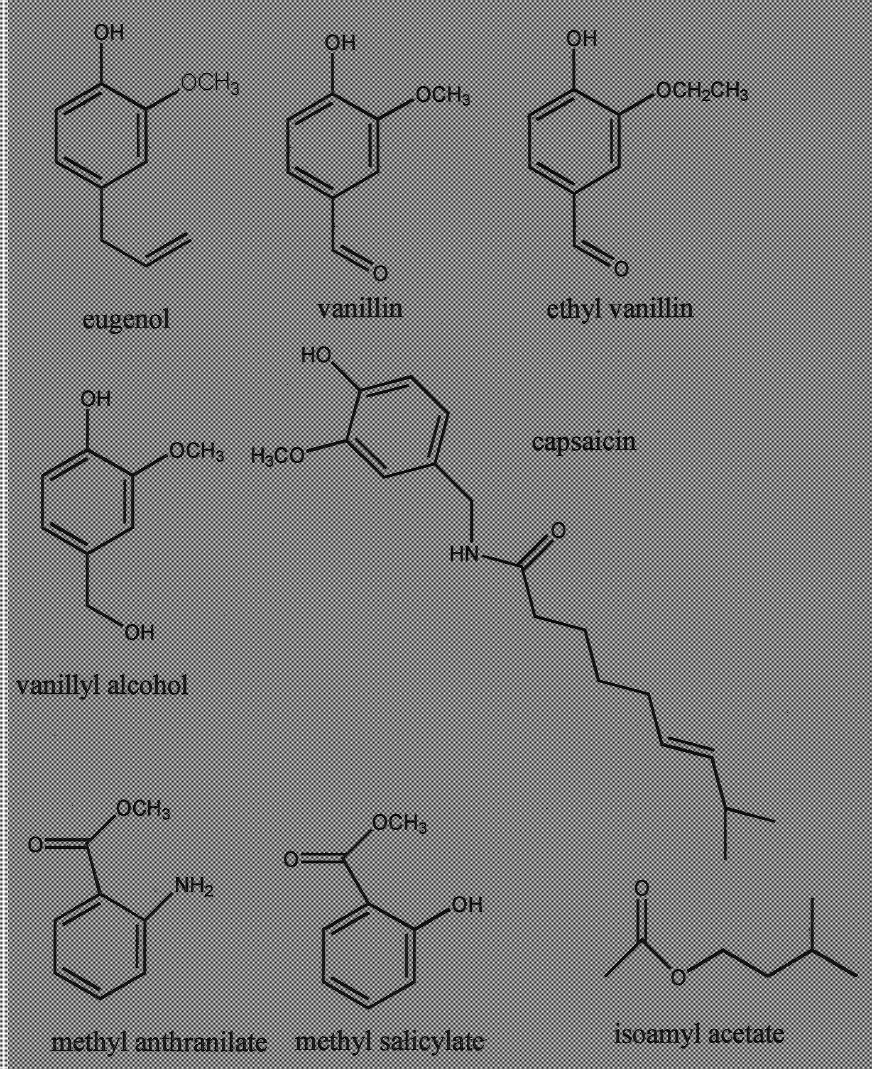

# Scented Terpenes

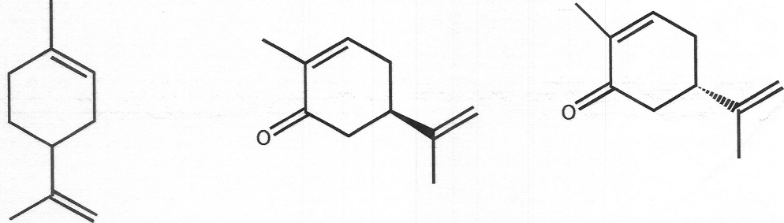

limonene R-(-)-carvone S-(+)-carvone

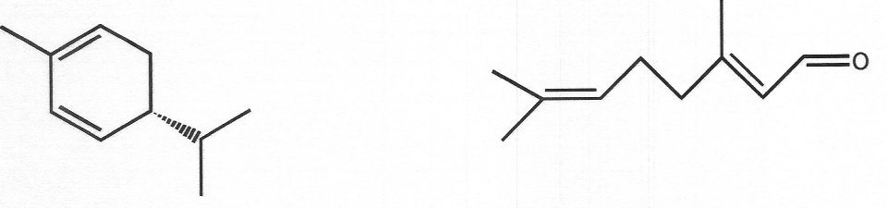

R-(+)-alpha-phellandrene citral ( a mixture of cis and trans)

# Experiment 1

**Fractional Distillation, Steam Distillation and Gas Chromatography**

Before coming to lab for the second week, please study all pages associated with this lab in this book and complete the following pre-lab questions in your laboratory notebook. If you feel shaky answering the questions, please feel free to consult the lab texts on reserve in the library.

**Prelab Questions**

1. When setting up a distillation apparatus, why is the heating mantle positioned several inches above the lab bench? Give three specific situations where this positioning might be advantageous, e.g. bumping over, etc. (5 points)
2. Explain the reason it is useful to add a boiling stone or two to your distilling flask. How do you think the stones work? (Hint: Though the stones are small, they have numerous channels passing through them. Sum total, theses channels have an enormous surface area. ) (5 points)
3. In a fractional distillation, explain the effect of distilling too fast. (5 points)
4. Briefly, and in your own words, describe how a basic GC works. It is best to explain this in terms of a specific example. (5 points)
5. In your own words, describe the fundamental differences between fractional and steam distillation. Address this issue from an apparatus and a theoretical perspective. (5 points)

During this two week lab you will separate an "unknown" solution of toluene/cyclohexane by fractional distillation. What is unknown is the percent composition of the solution. The composition of the unknown and the success of your distillation will be determined using gas chromatography. You will also isolate two natural products, eugenol and acetyl eugenol by steam distillation.

## Week 1

### *Fractional Distillation*

Obtain a 25-mL sample of an unknown solution of cyclohexane and toluene from your TA/instructor. Analyze this mixture by gas chromatography and then **stopper the solution and store it in your locker.**

***Steam Distillation***

1. In a 100 mL round-bottom flask, place 5.0 g of freshly ground cloves and 40 mL of water. Set up for steam distillation using a simple distillation apparatus using your micro kit as shown on the following page and demonstrated in the lab manual. Distill rapidly (80 volts on your step control) and collect approximately 15-20 mL of distillate.
2. Place your distillate in an Erlenmeyer flask, cork it and store it in your locker. You will complete the rest of the experiment next week. Can you find the clove oil in the distillate? If so, can you come up with a way to isolate it? Consider the fact that clove oil is very soluble in dichloromethane, but is insoluble in water. Also consider the relative boiling points of the constituents of clove oil and dichloromethane. Mull this over during the coming week and develop a simple plan for isolation.

## Week 2

1. Set up your distillation apparatus using the picture below as a guideline (see also the display apparatus in the laband the preceding photo on page 1-30). Use the equipment in your micro kit. Your glassware must be scrupulously dry. It is usually a waste of time to wash the glassware before you begin. Build it from the bottom up. Start with the flask heater, then the round-bottomed flask (add 20-25 mL of your cyclohexane/toluene mixture and a boiling stone), then the still-head, then the condenser, then the curved adapter. Attach the red (not black – black is vacuum tubing) rubber tubing last.



Note especially the following:

1. The flask heater is supported about 6 inches above the benchtop so that it can be lowered quickly in case of emergency. The bottom of the 50-mL flask is in light contact with the heater surface.
2. Use a small amount of stopcock grease on each joint as you assemble it. To grease joints, apply a small amount of grease to the inner part of the joint before insertion. Move the inner part around until the grease is spread. Grease is good, but remember, it is not glue.
3. A micro clamp is secured tightly around the neck of the flask, while a micro clamp can be used to loosely supporting the packed column. Support the West condenser with a micro clamp (or if we have a shortage, a two large pronged clamp). Use yellow Keck clips as additional support on round-bottom joint and the joint at the top of the column . Generally, it is good to keep clamps relatively loose is kept loose to avoid putting strain on the glassware and to allow for adjustments. DO NOT put a clamp on the still head. Use only the three clamps shown. Clamps are for support only, not to hold pieces together. The latter function is performed by rubber bands (see below). Keck clips are very fragile and should be used sparingly and gently.
4. Two rubber bands hold the pieces together. (Rubber bands are in plastic boxes on the ledges above your bench) These should be attached immediately upon joining the two pieces together. If you wait, the force of gravity will wind up costing money. Rubber bands are cheap and effective.
5. The thermometer bulb is just below the side arm of the still-head. It MUST be completely immersed in the vapor during the distillation in order to obtain an accurate boiling point. This is very important and frequently misunderstood. Do not use the mineral spirit (blue) thermometers (they tend to run about five degrees low, unless fully immersed). Use a **mercury thermometer** (silver)
6. The rubber tubing is forced all the way onto the connection joints. The best way to accomplish this is to wet the glass projections with water, then twist (rather than push) then tubing on. If the tubing is not securely attached, there is a high chance of its popping off at the least opportune time (namely when the water is running). Unlike the picture above, the water inlet and outlet should face down.
7. The rubber tubing is further secured with copper wire and pliers (also in plastic boxes on the ledges above your bench).
8. The distillate is collected in a 10-mL graduated cylinder, which may be supported with a mini clamp so that there is very little gap between it and the outlet of the curved adapter. This will minimize the escape of vapors. Do not support glassware on books, with piles of towels, or in other imaginative, but unstable ways.

3. The purpose of boiling chips/stones (which must be used when heating any liquid in the organic lab) is to provide a large surface area on which bubbles can form to promote smooth constant boiling. Otherwise most liquids will superheat (i.e. become hotter than their boiling points) and then, at the slightest disturbance, will boil over violently.It is good to think of what would happen if the boiling stone were not present. Most of the gas would form on the surface of the glass (at the interface with the heater where things are hottest), the bubbles would tend to be very large. The hot stone prevents the liquid from being superheated and the small bubbles released from the many channels in the stone do not push the liquid up violently.

1. Remember that the materials you are distilling are flammable. Be careful!
2. HAVE THE TA OR LAB INSTRUCTOR CHECK AND APPROVE YOUR APPARATUS BEFORE YOU START YOUR DISTILLATION. ARE YOU PLUGGED INTO THE STEP CONTROL?
3. Starting with a voltage control setting of 40-50 , begin distilling your unknown. Distill at a rate of ca. 0.5 drop/sec. into the receiver (maintain a continuous rate of ca. 0.5 drop/sec. or you may not finish the experiment) and collect the following fractions. Record the still head temperature after every collection of 1 mL of distillate. You will have to turn up the voltage constantly throughout this distillation. Whenever you do not make progress for over five minutes, turn up the voltage by 5 volts. Lack of progress is defined as follows.
4. When the liquid in the pot is not boiling.
5. When the condensate is not rising up the column.
6. When no distillate is coming over or when the distilling rate drops below 0.5 drop a second.

Fraction A: Ambient temperature to the end of the first "plateau" (ca. 88±5 °C). The temperature will begin to rise faster than it had been rising. This fraction should contain most of the cyclohexane.

Fraction B: Beginning of the large temperature rise (ca. 88±5 °C) to the beginning of the second "plateau" (ca. 108°C). This fraction should be small; it will contain substantial amounts of cyclohexane and toluene.

Fraction C: ca. 107 or 108 °C to 111 °C. This fraction should contain most of the toluene. Collect as much as you can, but DO NOT DISTILL TO DRYNESS.

Because you have only one 10-mL graduated cylinder in your locker, proceed as follows. Have three labelled (A, B, C) Erlenmeyer flasks (25 mL or 50 mL) with corksready or alternatively, use clean vials labelled A, B and C. Begin your distillation using your 10-mL graduated cylinder as the receiver for Fraction A. When you decide to change to Fraction B, replace the graduated cylinder temporarily with the "B" Erlenmeyer (or vial) , quickly pour the contents of the graduated cylinder into the "A" Erlenmeyer (or vial), cork that flask (or vial), and immediately resume collecting the distillate in the graduated cylinder. Make an analogous maneuver involving the temporary use of the "C" Erlenmeyer (or vial) as a receiver when you decide it is time to change to Fraction C.

7. Remember that the decision to change receivers should not be made on the basis of head temperature alone, but rather on the changes and pattern of the change in head temperature. Only when the temperature begins to rise significantly after the first temperature "plateau" should you change receivers from Fraction A to Fraction B. The exact temperature at which this change should be made will depend on the composition of the mixture with which you start. For example, a mixture that is richer in cyclohexane than toluene will start its first temperature rise several degrees below 88 °C; similarly, a toluene-rich mixture will start several degrees above 88 °C. The temperature at which the change from Fraction B to Fraction C is made should not depend to any appreciable extent on the original composition of the mixture. Why?

8. In any distillation you carry out, NEVER LET THE POT GO DRY. When the volume in the distilling flask is about 1 mL (just covering the boiling chips), lower the heater, turn off the heat, and allow the system to cool. Small amounts of nonvolatile impurities including organic peroxides may be present in any liquid. These will be concentrated by the distillation of more volatile materials. The sharp rise in temperature that occurs quickly upon complete removal of the solvent can sometimes result in a serious explosion of such materials.

9. Analyze samples of Fractions A, B, and C, and also the undistilled sample of your original mixture by gas chromatography. Your instructor will teach you how to use the instrument. Note that details regarding the conditions for this particular analysis and a sample trace of a mixture of cyclohexane and toluene are posted on each instrument. This information about conditions should be recorded on your own GC trace. Under the conditions of the analysis, cyclohexane has a shorter retention time than toluene.

If there is a long line at the GC, save ca. 1 mL of each fraction in vials and pour the balance of the liquid in the 50 mL round - bottom. Continue with the simple distillation as described below. You can analyze your samples later or on another day.

10. The detelinination of the relative amounts of various compounds separated by gas chromatography must begin with the measurement of the area under each peak. The integrators automatically calculate the relative areas for you. You will find these values on your GC trace.

### *Simple Distillation*

1. When you are finished with your fractional distillation, combine all the fractions and the pot residue in the 50 mL round- bottom. Remove the packed distilling column and associated clamp. Attach the filled round bottom to the still head. Raise the heater to meet the round bottom. Please ask for help from your instructor if you are having trouble making this transition. Begin heating with a voltage setting of 40-50.
2. Carry out a simple distillation. Try to achieve a rate of distillation comparable to your fractional distillation. You do not need to collect formal fractions, but record distillate volume versus still head temperature as you did for the fractional distillation (every 1 mL).

This data will be useful when you are doing your write-up.

1. Distill until you have ca. 1-2 mL left in the round bottom.
2. Pour the collected distillate and pot residue into the designated waste bottle. THIS EXPERIMENT IS NEARLY COMPLETELY RECYCLABLE. IF YOU DO NOT FOLLOW INSTRUCTIONS, YOU WILL CAUSE UNNECESSARY WASTE AND POLLUTION.

### *Steam Distillation of Eugenol : Final Isolation of Eugenol*

1. Using your simple plan, isolate your eugenol, determine its mass and then subject it to olfactory analysis. Please compare/contrast its scent with vanillin, ethyl vanillin and vanillyl alcohol. Samples of these compounds can be found in the lab. Please note that this is the first and last time you will use scent as a means of chemical analysis. Do not directly smell compounds.
2. Calculate the percent yield of eugenol obtained considering the fact that clove oil is approximately 17 % clove by weight of cloves.

Note:

*% yield = ((Mass of eugenol obtained) ÷ (mass of eugenol expected (theoretical))) X 100*

Distilling is beautiful. First of all, because it is a slow, philosophic, and silent occupation, which keeps you busy but gives you time to think of other things, somewhat like riding a bike. Then, because it involves a metamorphosis from liquid to vapor (invisible), and from this once again to liquid; but in this double journey, up and down, purity is attained, an ambiguous and fascinating condition, which starts with chemistry and goes very far. And finally, when you set about distilling, you acquire the consciousness of repeating a ritual consecrated by the centuries, almost a religious act, in which from imperfect material you obtain the essence.

Primo Levi, The Periodic Table

# Lab Report

**As described in lecture, the first few lab reports will not be normal investigative or preparative reports. We are going to take some time to work our way into writing detailed, molecular level laboratory reports. Please only include what is listed below.**

1. Answer all pre lab questions. (25 points)
2. A report all raw and processed data

a. fractional distillation

1. All GC traces (12 points)
2. A tabulation of all GC data (8 points)
3. A plot of still head temperature vs. volume for the simple and fractional distillations (10 points) This does not have to be done via computer.

b. steam distillation

1. Mass of clove oil (eugenol and acetyl eugenol)l obtained (4 points)
2. Percent recovery of clove oil essential oil (6 points)   
   (note: % recovery = ((mass eugenol isolated) ÷ (mass of clove )) X 100)

3. Percent yield of clove oil essential oil ( 6 points) (note: *% yield = (Mass of eugenol obtained) ÷ (mass of eugenol expected (theoretical)) X 100)*

1. Comparison of the scent of clove oil essential oil to the others provided vanilloids (10 points)

3. The answers to the following questions

1. In your own words describe how a distilling column works. (10 points)
2. Now that you know the composition of your unknown, estimate (very roughly, no calculation required) the boiling point of the unseparated unknown. In terms of intermolecular forces, explain your estimated boiling point. (6 points)
3. Estimate the boiling point of a liquid at 20 torr that boils at 230°C at 760 torr. For a rough estimate assume the following. Each time the atmospheric pressure is halved, the boiling point drops 10 °C. This is a very rough estimate. (4 points)
4. Explain at a molecular or structural level why cyclohexane has a lower GC retention time than toluene. (6 points)
5. We did not complete the steam distillation. How can you generally tell if a steam distillation is finished? How much water would it have taken to exhaustively isolate all the clove oil in your sample? (12 points)
6. Examine the plots of the fractional vs. simple distillation you prepared earlier in your write-up. Describe and explain the differences. (12 points)
7. Specifically describe where material was lost in the eugenol procedure. (10 (points)
8. List all errors that lead to less than ideal results in your fractional distillation procedure. (10 points)

For your information, the following is the definition of a successful fractional distillation:

1. An A fraction that is enriched in cyclohexane relative to the unknown.
2. A B fraction that is similar in composition to the unknown.
3. A C fraction that is enriched in toluene relative to the unknown.
4. A small B fraction (6-10 mL).
5. A "long" plateau occurring over a relatively small temperature range for the A and/or C fractions.