Chemistry 211-212 Cover Sheet
Name: __________________________ | TA Name: ________________________
Friedel Crafts Reaction: Alkylation of
Xylene, Kinetic and Thermodynamic Reactions Part I Kinetic Control

Page 1 Worksheet (Pre-lab) | ______________ ( 20 Points)
Page 2 Worksheet | ______________ ( 28 Points)
Page 3 Worksheet | ______________ ( 30 Points)
Page 4 Worksheet | ______________ ( 22 Points)
Page 5 Worksheet | ______________ ( 36 Points)
Quality of results | ______________ ( 20 Points)
Total | ______________ (146 Points)
Score | ______________ % (percent)

This is your report cover. Please fill this form out and attach it to your form.
Friedel-Crafts Reaction: Alkylation of Xylene, Kinetic vs. Thermodynamic Control
Part I: Kinetic Control
General Safety Considerations
- AlCl₃ reacts violently with H₂O liberating HCI gas. Be careful when you open AICI₃ bottle (keep your nose out of it). Make sure you tightly cap the bottle when you are finished. Do not allow your AICI₃ to sit around exposed to the atmosphere. It will react with the atmospheric H₂O and deactivate. When you measure out the AICI₃ you should immediately transfer it into a very dry round-bottom (the reaction flask) and immediately cover the aluminum chloride with the p-xylene. The p-xylene will create a barrier to the atmospheric H₂0. Generally, wear gloves and goggles. In the event of a spill, consult your instructor immediately.
- p-Xylene, 1-bromobutane and 1-bromopropane are irritants and toxic. Take all the normal precautions to avoid exposure. Keep the chemicals in the hood as much as possible. Wear gloves and goggles. In the event of a major spill, consult your instructor. if you come in contact with these substances, flush the exposed area for fifteen minutes with cold water.

Flow Chart
Friedel Crafts Reaction: Alkylation of Xylene, Kinetic VS. Thermodynamic Control, Part I Kinetic Control

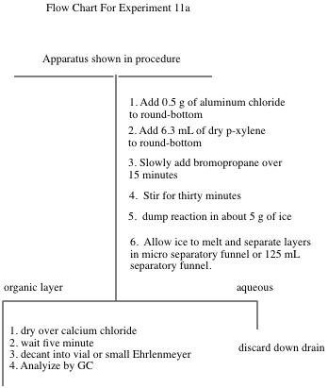

Friedel-Crafts Reaction: Alkylation of Xylene, Kinetic vs. Thermodynamic Control, Part I Kinetic Control

“Science repulses the indefinite.”
Claude Bernard (1813-78), Introduction L’Etude de la Medecine Experimentale (1865)
In preparation for this investigation, carefully study the Friedel-Crafts Reaction in your textbook (chapters 14 and 15) view any provided youtube videos and answer the pre-lab questions on the form that follows the procedures in this lab. It is also expected that you will attend lab lecture (this is preferential or if you cannot, that you view the lab lecture available on tegrity, see link on moodle). This semester attendence and number of tegrity views will be tracked. It is important to be well prepared for lab.
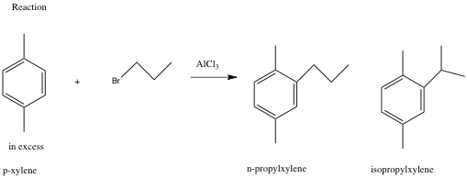
This exercise is an excellent example of the kind of experiments that are done in order to investigate the mechanism of a reaction. Your objectives are to carry out the Friedel-Crafts alkylation of p-xylene with 1-bromopropane and analyze the products by GC. The expected products are n-propyl-p-xylene and iso-propyl-p-xylene. You will determine the ratio of these products by GC. The extent of isomerization of the alkyl group from n-propyl to iso-propyl gives information on the rate of rearrangement versus the rate of alkylation. You will compare that information with the ratio of products found in the alkylation of benzene.

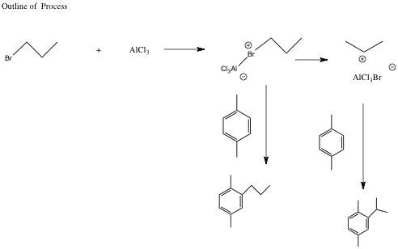
A. Procedure:
- Set up the apparatus shown on the top of the next page in the hood using drierite in the curved adapter. The method to pack the drying tube (the curved adapter filled with drierite) is as follows. Wearing gloves, put a small amount of glass wool in the curved adapter. Add enough drierite using a spatula to nearly fill the tube. Then place a small piece of glass wool at the end of the tube. If the drierite is dry, the colored drierite will be blue. If it has absorbed significant water, it will take on a reddish/pink color. If the drierite becomes wet during the reaction, it should be replaced. In building your apparatus, you should be using your 14/20 micro glassware and the round-bottom should be a 25 mL round-bottom. Set a magnetic stirrer under the round-bottomed flask. Take the addition funnel to the hood and add to it 0.025 mole of 1- bromopropane. Stopper the funnel with an appropriate septum cap and reconnect it to the apparatus. Place a small magnetic stirring bar in the 25 mL roundbottom flask and bring it and a small septum cap to the hood. Place 0.5 g of aluminum chloride in the flask and immediately cover it with 6.3 mL of dry p-xylene (the point is to minimize exposure of AlCl₃ to moisture in the air). Quickly reconnect the flask to the apparatus.
- With the stirrer on, add the 1-bromopropane dropwise (1 drop or less per second – you may have to close the stopcock occasionally). After addition is complete (about 8-15 minutes), allow the mixture to react an additional 30 minutes. If your addition is faster than 15 minutes, make the total time 45 minues.
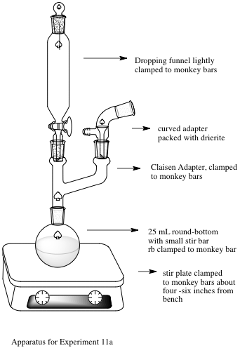

Friedel Crafts Apparatus
- Pour the mixture into a 50 mL beaker containing about 5 g of ice . Stir until the ice has melted, then transfer to a 25 or 30-mL separatory funnel, separate the layers, and discard the aqueous layer. Dry the organic layer over anhydrous CaCl₂ for about 5 minutes. Note: It is expected that you can dry independently. What are you looking for in drying? Answer: clarity of the solution and new CaCl₂ remaining unclumped (not sticking to other pieces of calcium chloride). Note the more you shake CaCl₂ the more it fragments and the cloudier it becomes. So it is suggested that you refrain from shaking too much.
- Filter or decant the solution into a small Ehrlenmeyer flask or vial and carry out a preliminary GC analysis of the solution. If you have sensitivity problems with the GC, adjustment of the concentration of the sample may be necessary. Please see your instructor if you are having trouble with the GC. It is necessary to store the GC data, but it is not necessary to print the data. Please record the retention times and percentages of the peaks directly from the computer. This is an effort to save paper. If no one is waiting, you can send the table to your email (not the trace).

B. Lab Report
A standard lab report will not be required for this lab. If you complete the attached form, you have finished the lab write-up.

Friedel Crafts: Alkylation of Xylene Kinetic vs. Thermodynamic Control: Part I: Kinetic Control
Form Write-up
Name:________________________________Exp. name:
T.A. Name Date:
I. Pre-lab Exercises
- Why is it essential to use a gas trap and to work in the hood while carrying out this experiment? (5 points)
- Why is a drying tube used in this experiment? (5 points)
- What side reaction will occur if the glassware used is not dry? (5 points) . D. Why is an excess of p-xylene used in this experiment? (5 points)
II. Experiment and Results
- Include a table of your GC data in your report – retention times and percent areas. You can record this in your notebook directly from the GC computer. (10 points)
- Report the ratio of products in percent form for the reaction excluding unreacted p-xylene. ( 8 points)
III, Discussion/ Conclusions
A. Discussion of Rate of Rearrangement vs. Rate of Substitution. This is very important and should include structures and include the overall mechanism of the reaction. ( 20 points)

B. Error Analysis. Focus on errors that might alter the ratio of products. (10 points)

IV. Post-lab Questions
A. Go to nmrdb.org and simulate and interpret the NMR of n-propylxylene and isopropylxylene. (10 points)
B. Write a complete mechanism (arrow formalism, resonance structures) explaining the formation of the two products. (8 points)
C. Why was the reaction mixture poured on ice at the end of the reaction, Write equations to describe any chemistry occurring in this step. (4 points)
D. Approximately what ratio of rearranged to unrearranged products do you expect if toluene (methyl benzene) is subjected to the reaction carried out in this lab? (8 points)
E. Given the fact that the reaction you just did is kinetically controlled, what do you suppose might happen if the temperature of the reaction was raised enough to cause equilibration. (8 points)
V. Quality of Results (20 points) This is determined by the TAs.

